Last Update: 04/17/26
Clean Air Act PERMIT SYSTEM (CAAPS) USER GUIDE
Contents
1.0 Introduction 3
2.0 Permits Module 4
2.1 Permitting Authority Preparer Users 4
2.1.1 Navigating the Permitting Authority Landing Page 4
2.1.2 Creating a New PM Form (Permits Module) 6
2.1.3 PM Form Data Entry (Permits Module) 7
2.1.4 Linking Existing Facilities (Permit Module) 9
2.1.5 Uploading Supporting Documentation (Permits Module) 15
2.1.6 Submitting a PM Form (Permits Module) 18
2.1.7 Resubmitting a PM Form (Permits Module) 20
2.1.8 Accessing the Permit Review Page 25
2.1.9 Navigating to the RACT/BACT/LAER Clearinghouse (RBLC) Data Entry Module (DEM) 27
2.2 RBLC Permitting Authority Preparer Users 29
2.2.1 Navigating the Permitting Authority Landing Page 30
2.2.2 Creating a New PM Form (Permits Module) 31
2.2.3 PM Form Data Entry (Permits Module) 31
2.2.4 Linking Existing Facilities (Permits Module) 32
2.2.5 Entering Final Permit Data (Permits Module) 37
2.2.6 Submitting a PM Form (Permits Module) 38
2.2.7 Accessing the Permit Review Page 40
2.2.8 Navigating to the RACT/BACT/LAER Clearinghouse (RBLC) Data Entry Module (DEM) 42
3.0 RBLC Data Entry Module (RBLC DEM) 44
3.1 RACT/BACT/LAER Information DEF 44
3.2 Uploading Supporting Documentation 48
3.3 Submitting a DEM form 52
4.0 Glossary 54

1.0 Introduction
This user guide explains how to utilize the Clean Air Act Permit System (CAAPS), previously referred to as the Electronic Permit System (EPS).
The main purpose of CAAPS is to provide a centralized platform to collect, and store, documents and data from State/Local/Tribal Permitting Authorities (SLT PAs) and permit applicants, to allow EPA to provide permit review oversight and issue U.S. Environmental Protection Agency (EPA) permits. An additional objective of CAAPS is to provide permitting information to the public in accordance with the Clean Air Act (CAA). An SLT Permitting Authority (PA) is any SLT agency with an approved/delegated permitting program to issue CAA permits; there are also EPA-issued CAA permits, where EPA is the PA. Some of these permits, and associated documents, are submitted to meet regulatory requirements associated with permitting programs, and others are submitted voluntarily. For each submittal, when applicable, CAAPS tracks where the permit is in the review process for EPA’s Title V permitting regulatory 45-day review and the petition period that follows.
CAAPS is broken into two modules: the Permits Module (PM) and the RBLC DEM. There are two distinct user roles within CAAPS: the Permitting Authority Preparer (PAP) role and the Reasonably Available Control Technology/Best Available Control Technology/Lowest Achievable Emission Rate Clearinghouse-Permitting Authority Preparer (RBLC-PAP) role. These roles involve different workflows and are separated to ensure that users interact only with the processes relevant to their air permitting activities.
When interacting with the Permits Module (PM), PAP users prepare and submit permit actions forms (PM form) for each step of the permitting lifecycle, receiving EPA’s review during the process via the CAAPS application. Their work involves uploading required documentation to the PM, completing all required fields within the PM, and participating in the EPA permit review cycle.
When interacting with the PM, RBLC-PAP users focus on preparing and submitting only Final Permit data to EPA. These users enter limited permit-related information into CAAPS but will not upload supporting documentation in the PM. RBLC-PAP submissions do not undergo EPA review and follow a different, more streamlined workflow. RBLC-PAP users will not be able to edit or resubmit their PM form once submitted.
The Reasonably Available Control Technology/ Best Available Control Technology/Lowest Achievable Emission Rate Clearinghouse (RBLC) Data Entry Module (DEM) gives designated users from SLT PAs the opportunity to submit pollution prevention and control technology data and documentation for stationary air pollution sources to help future permit applicants and reviewers make pollution prevention and control technology decisions for similar stationary air pollution sources. DEM Forms made in the RBLC DEM must occur after a final permit is issued because the entries need to reflect the air pollution control technology requirements that are included in the final permit. All pollution prevention and control technology decision data and documentation will become available for the public to search for and view on the RBLC Search Dashboard.
Because these roles serve distinct purposes, the system prevents users from registering for both RBLC-PAP and PAP roles for a given PA. This separation is designed to ensure that users only interact with the modules and workflow relevant to their assigned responsibilities, reducing confusion and maintaining data integrity within CAAPS. Both PAP users and RBLC-PAP users complete the PM before moving on to the RBLC DEM. Not all permit actions require completion of the RBLC DEM. For more information on which permit actions require an RBLC DEM submission see the “Note” at the bottom of Section 2.1.9.
For additional information on how to register for CAAPS, please see find the “Registering as a Preparer” user guide in the CAAPS CDX FAQ’s subsection. Users should consult with their EPA and SLT PA Points of Contact (POCs) to determine which role best aligns with their work, as the PAP and RBLC-PAP roles involve different levels of data entry, documentation requirements, and interaction with the EPA review cycle. Depending on how your PA plans to interact with CAAPS will determine which role is appropriate: PAP users should navigate to Section 2.1 for detailed guidance, while RBLC-PAP users should refer to Section 2.2.

2.0 Permits Module
The PM is used by SLT PAs to prepare and submit clean air act permit actions. The PM supports both the complete permitting lifecycle activities performed by the PAP users and the streamlined final permit submissions performed by the RBLC-PAP users. All users, whether PAP or RBLC-PAP, start out in the PM. Depending on how your SLT PA plans to interact with, CAAPS will determine which role is appropriate: PAP users should navigate to Section 2.1 for detailed guidance, while RBLC-PAP users should refer to Section 2.2.

2.1 Permitting Authority Preparer Users
PAP users perform full permitting lifecycle work in the PM. Their workflow includes submission of draft, proposed permits, and final permits, with the system retaining each submission as part of one “Permit Package.” PAP users will enter data in multiple pages of a permit action and upload supporting documentation. PAP users then submit permit actions for EPA review. PAP users participate in the EPA review cycle, which may require responding to comments and/or revising permit actions via resubmission. PAP users manage ongoing interactions with EPA throughout the permitting process.
The subsequent sub-sections provide a walk-through of the user interface.

2.1.1 Navigating the Permitting Authority Landing Page
The “Permitting Authority Landing” (PAL) page “Air Permits” table houses all pending and submitted permit actions for a given PA. Permit actions submitted to EPA have a value of “Submitted” and “Resubmitted” in the “Status” column and pending permit actions that are still being worked on have statuses of “Pending” and “Revision in Progress.” The table also allows users to (1) sort, (2) search, and (3) export data to an Excel file (Figure 1).
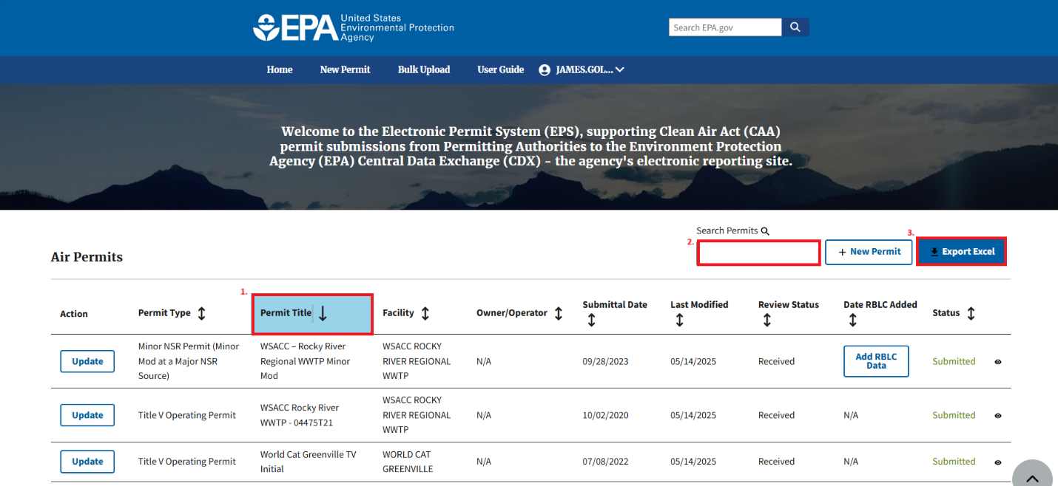
Figure 1
Users can click the “Permit Title” hyperlink for permit actions with a “Pending” or “Revision in Progress” status to be redirected to the in-progress permit action within the PM. There, users can finish data entry and submit their PM form. Users can click the eye icon for permit actions with a “Submitted” or “Resubmitted” status to be redirected to the “Permit Review Page”, which displays a summary of the PM form in a read-only state (Figure 2). For more information on the “Permit Review Page”, see Section 2.1.8.
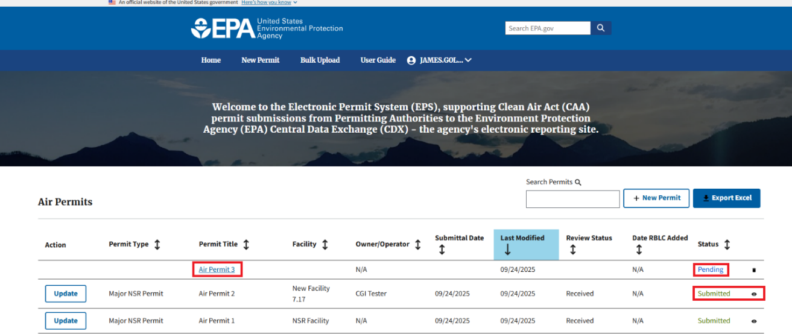
Figure 2
For permit actions with a “Pending” or “Revision in Progress” status, users can click the trash can icon (Figure 3) and click the “Continue” button in the confirmation modal, to delete in progress permit actions (Figure 4.) When a permit action with “Revision in Progress” status is deleted, the table displays the most recently submitted version of the Permit Package. The resubmission feature and the “Revision in Progress” status are explained more in Section 2.1.7.
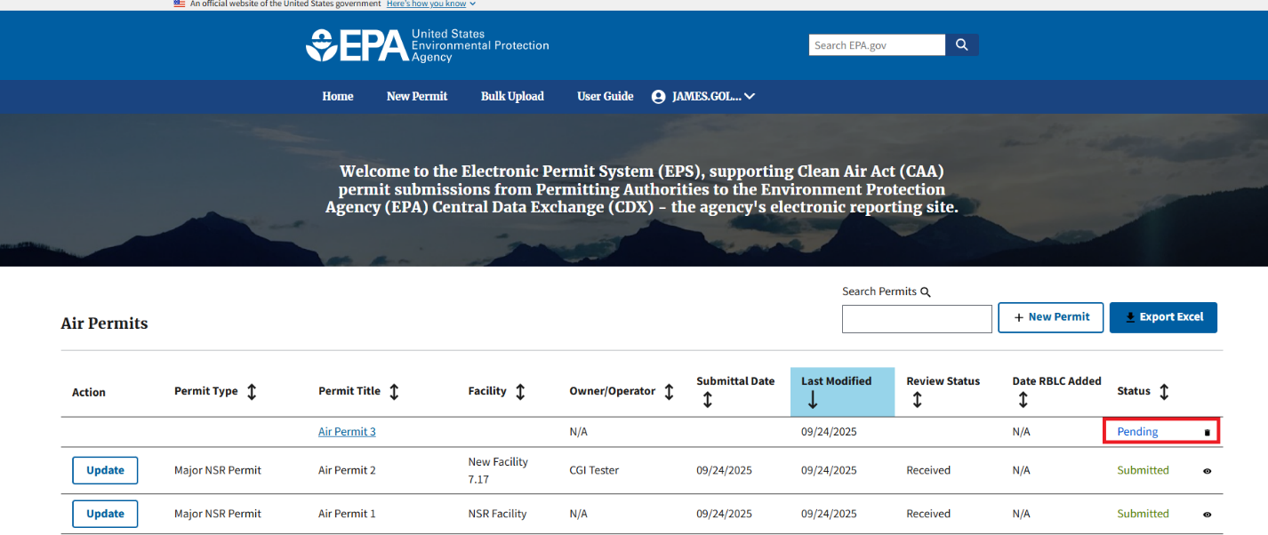
Figure 3
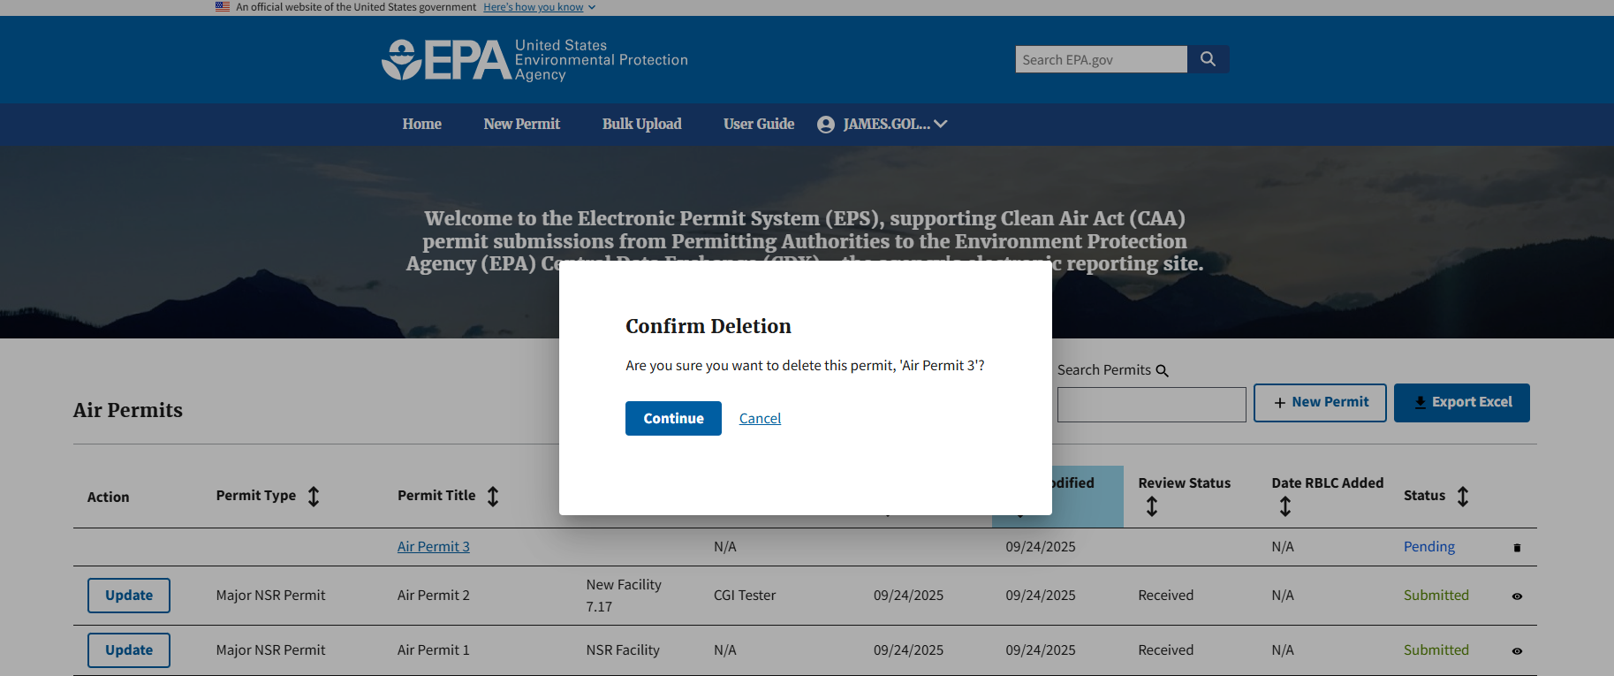
Figure 4
Note: The “Date RBLC Added” column on the PAL “Air Permits” table is related to actions that will be taken in the RBLC DEM. For detailed guidance, users should refer to Section 2.1.9.

2.1.2 Creating a New PM Form (Permits Module)
Clicking the “+ New Permit” button on the top right corner of the “Air Permits” table or clicking the “New Permit” tool bar link redirects users to a new PM form. From there, users can begin data entry (Figure 5.)
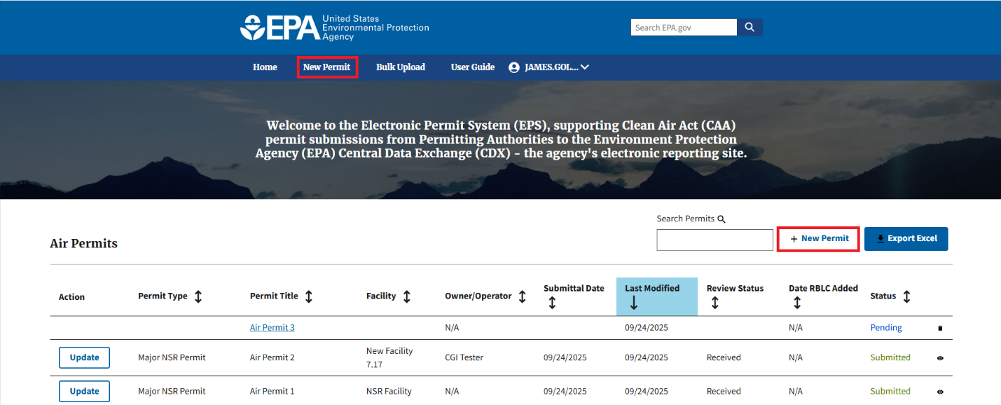
Figure 5

2.1.3 PM Form Data Entry (Permits Module)
Once users have initiated a new PM form, users can add information to the following pages of the form (Figure 6):

- Permit Title and Source
- Source Information
- Permit Action Information
- Supporting Information
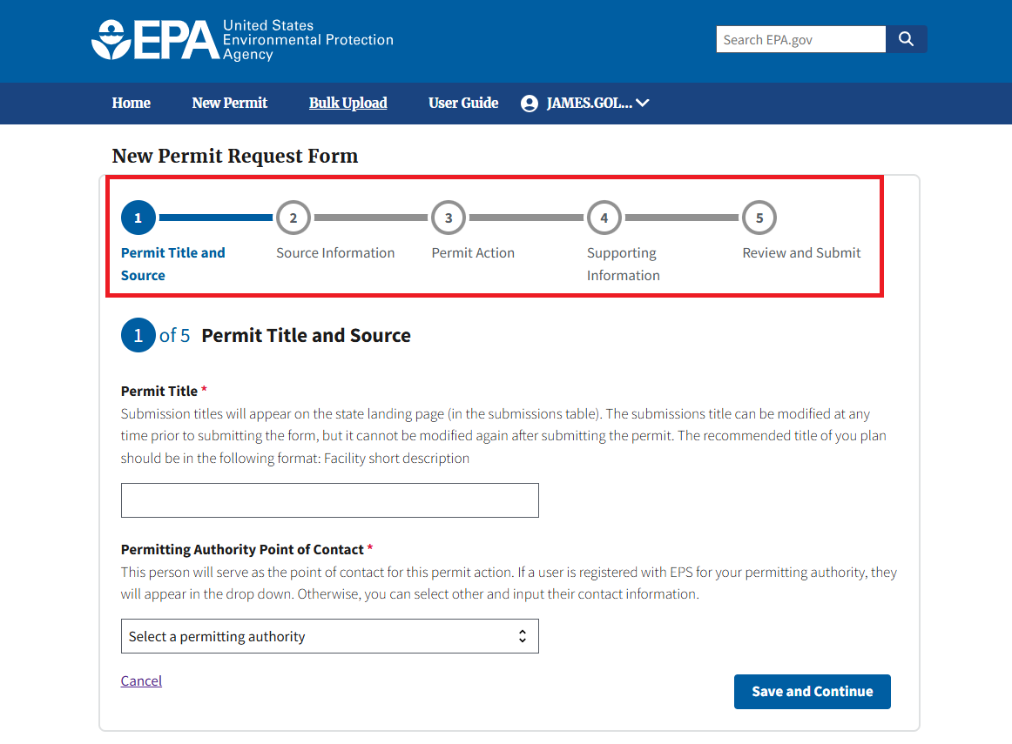
Figure 6
After users complete all required fields on page 1, click the “Save and Continue” button to navigate to the next page within the form (Figure 7.) Users cannot navigate throughout the form until page 1 is saved. If at any point while entering data within the PM form users need to save and come back later, click the “Home” link on the top toolbar to be redirected to the “Air Permits” table. The permit action will display a status of “Pending” in the “Status” column.

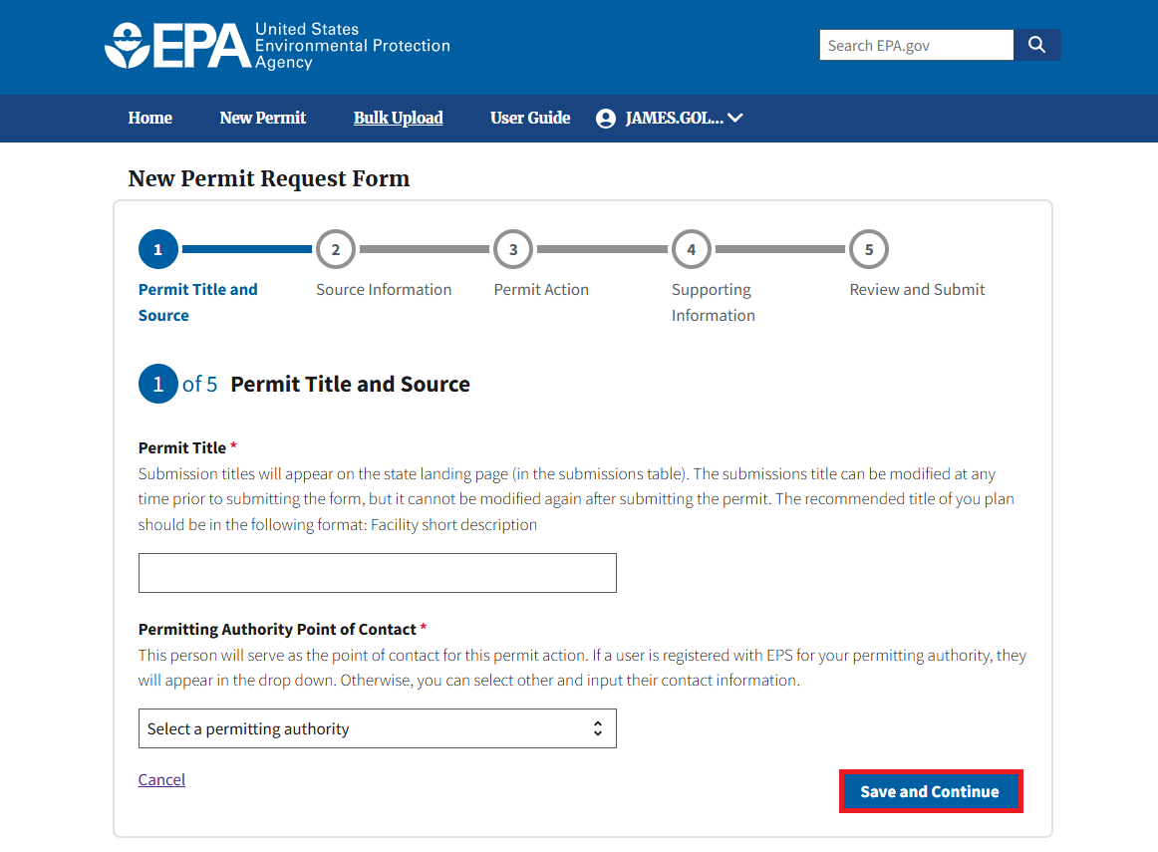
Figure 7

2.1.4 Linking Existing Facilities (Permit Module)
After completing the fields on the first page, users will proceed to the “Source Information” page where users are able to link their permit action to a facility (Figure 8.)
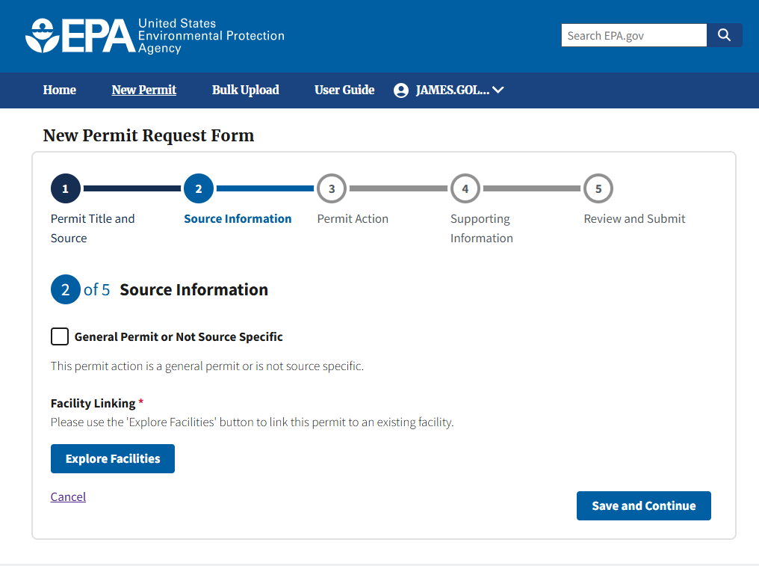
Figure 8
Click the “Explore Facilities” button (Figure 9) to open the “Explore Facilities” modal. Users can search for facilities previously used in CAAPS via Zone Improvement Plan (ZIP) code. Additionally, if users are searching for an existing “Mobile” or “Offshore” facility, users can do so using the corresponding checkboxes (Figure 10.)
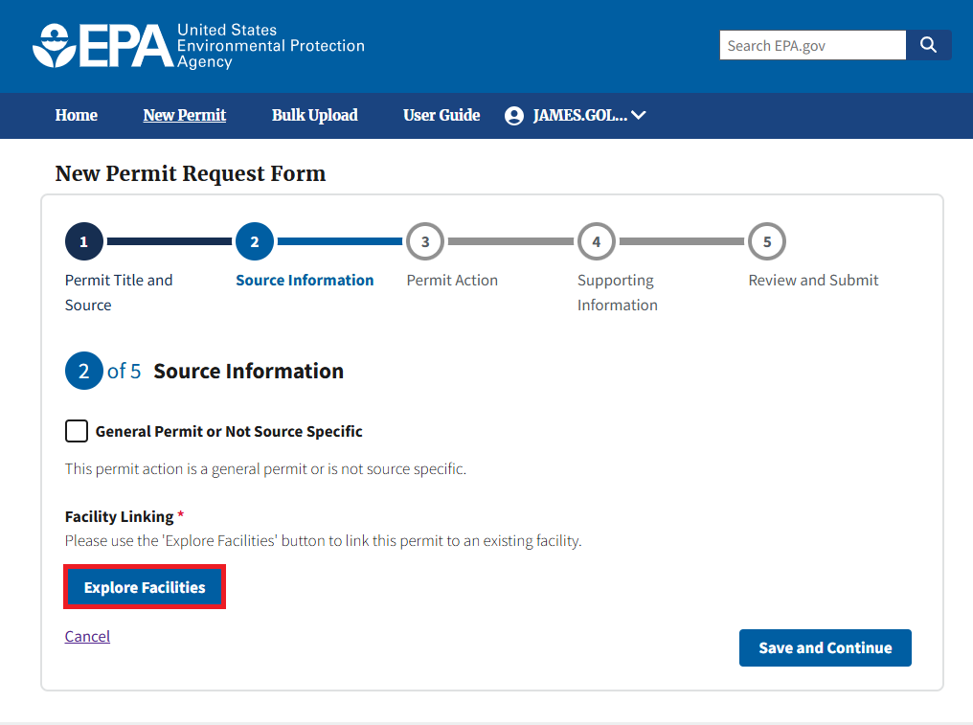
Figure 9
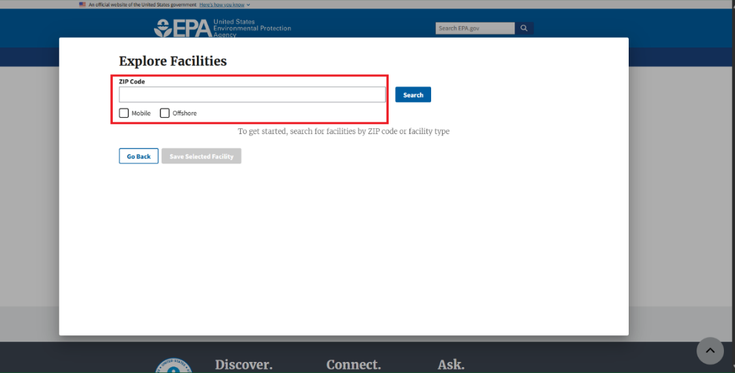
Figure 10
Once users enter the needed ZIP code or select one of the “Mobile” or “Offshore” options, click the “Search” button to return facilities matching the search parameters (Figure 11.) Users can select the appropriate facility and then click the “Save Selected Facility” button to link the facility to their PM form (Figure 12.)
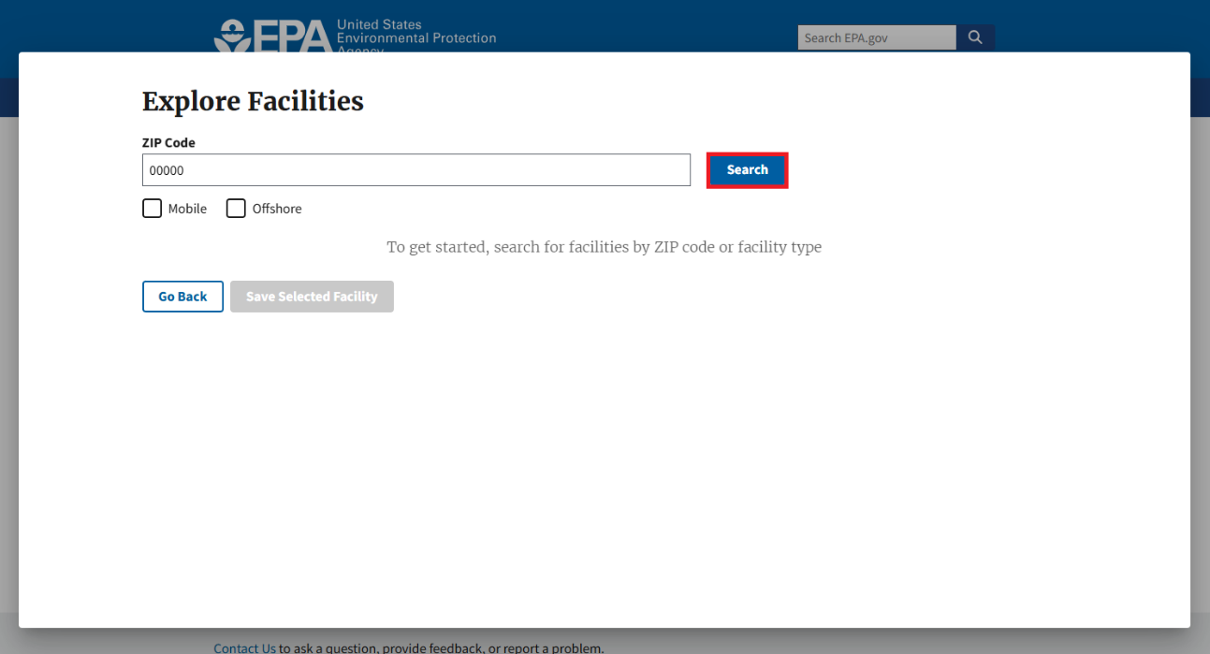
Figure 11
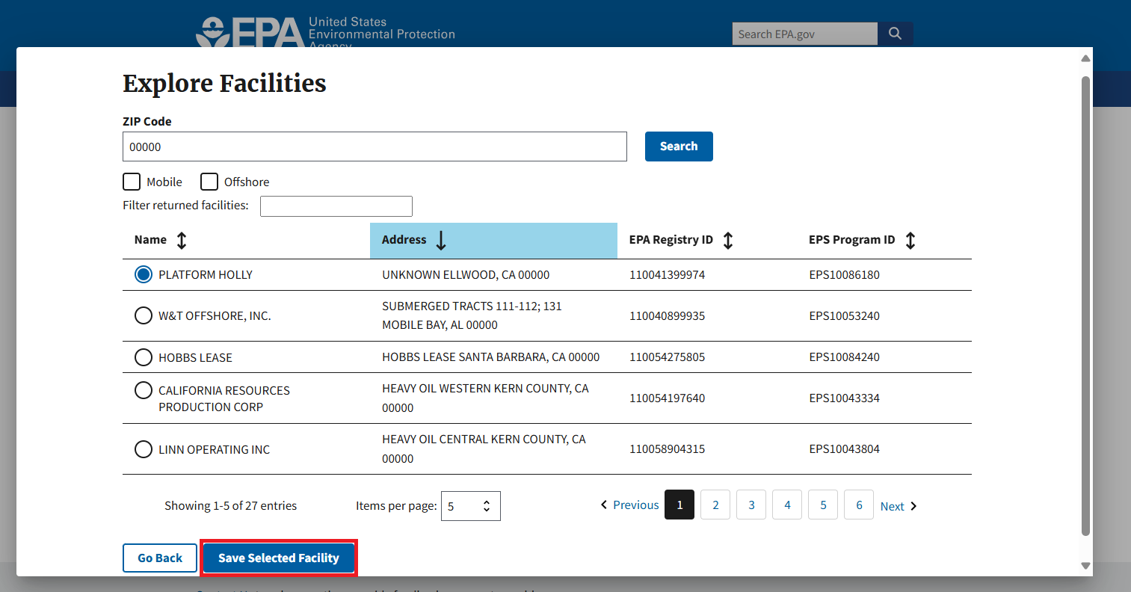
Figure 12

After clicking the “Save Selected Facility” button, users are taken back to the “Source Information page where the selected facility’s data is now prepopulated (Figure 13.)
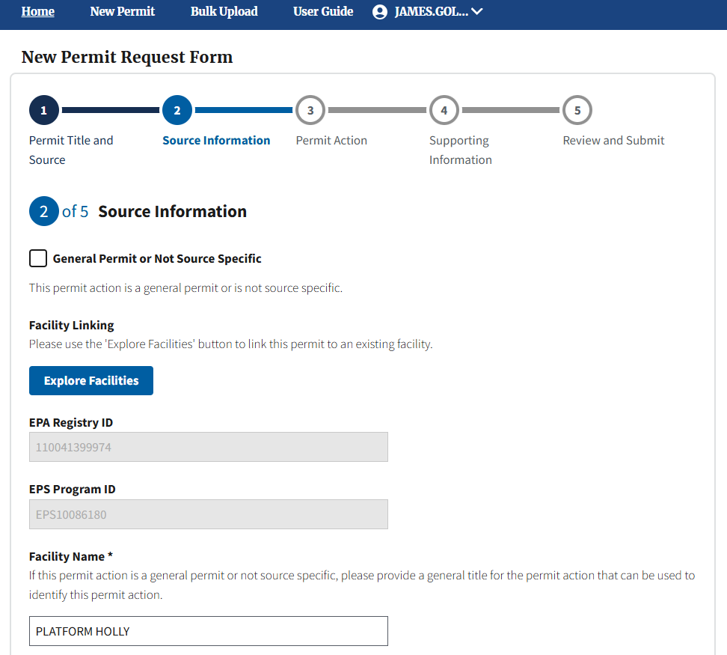
Figure 13
Users can make any necessary changes to the associated facility data on this page. Once the permit action is submitted, any updates to the facility are then applied to that facility’s record and will show on future permit actions that use the same facility. Permit actions associated with that facility that were submitted prior to their updates will maintain the same facility data that was associated with the facility at the time of their prior submission.
If users cannot find their facility or need to create a new facility, click the “Search” button and then click “here” at the bottom of the screen to complete manual data entry of the facility-related fields on the “Source Information” page (Figure 14.) Once submitted, the new facility will be available to search via ZIP code for any future user that needs to submit on behalf of the facility.
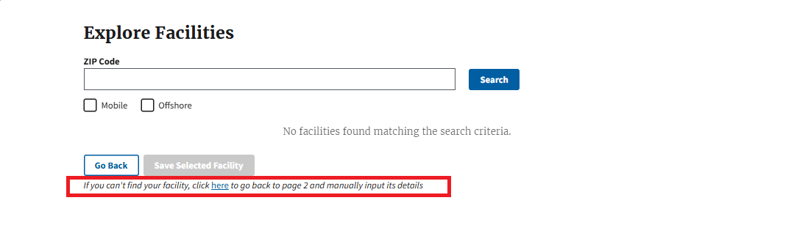
Figure 14
Regardless of whether a user is linking to a facility or creating a new facility, users must select the “Verify Address” button (Figure 15) before being able to “Save and Continue” on the “Source Information” page.
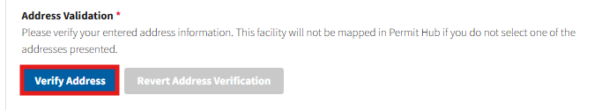
Figure 15
Once “Verify Address” is selected, users will receive a modal with address suggestions based on the facility address data provided. If the service provides a match, users can select the suggested address to automatically fill in the remaining address data fields for the facility. Users can select “Close” to elect not to use the suggested address candidates returned and continue manually enter the remaining facility data (Figure 16.)
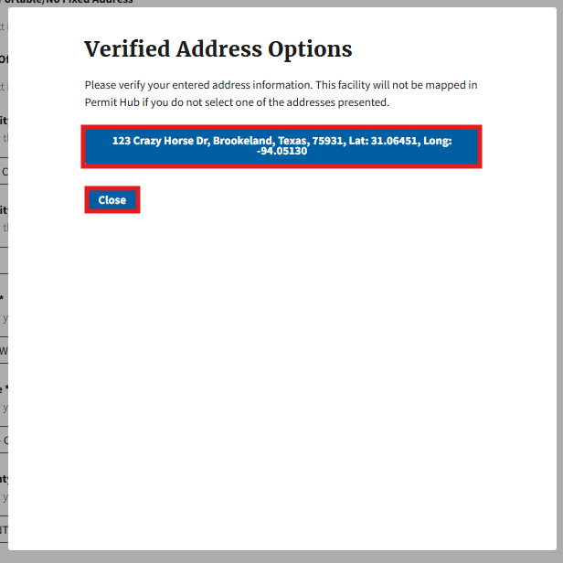
Figure 16

2.1.5 Uploading Supporting Documentation (Permits Module)
After completing all fields on the first three pages, users can proceed to the “Supporting Information” page (Figure 17) where they can upload all supporting documentation related to the submission. These documents help EPA review the permit action. Users can add as many supporting documents as needed on this page.
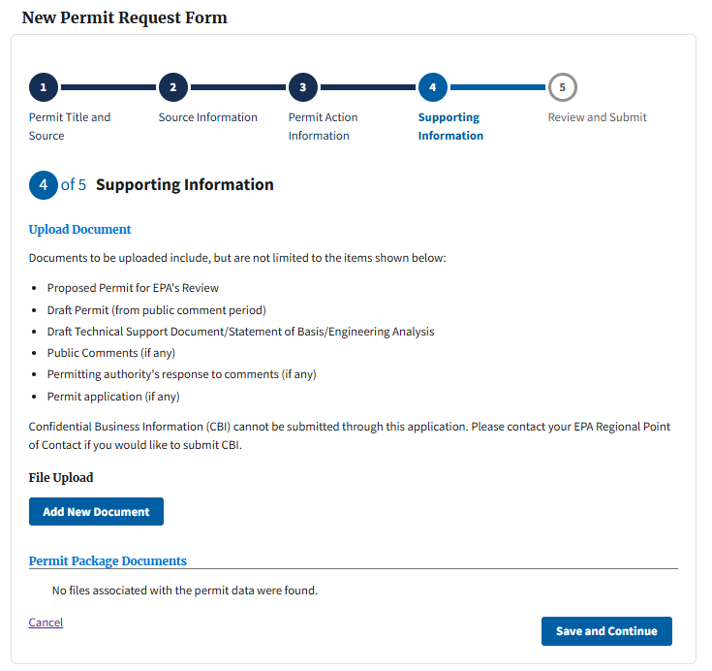
Figure 17

Click “Add New Document” (Figure 18) under the “File Upload” header to open the File Upload modal.
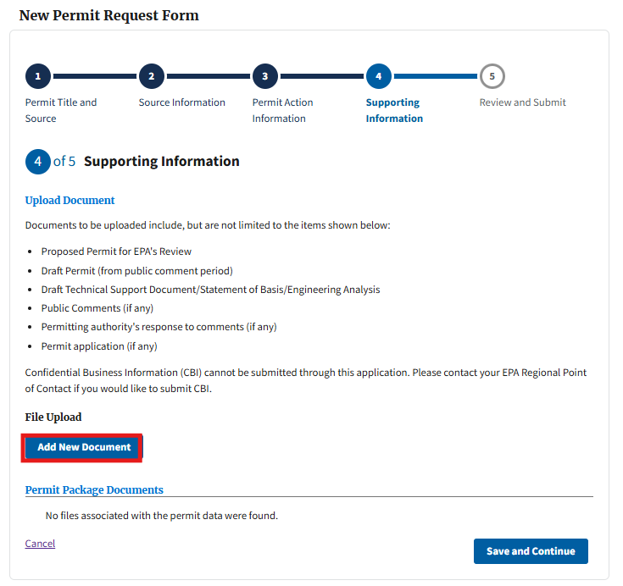
Figure 18
A list of the supported file types is provided on the modal. Users can either drag and drop any supported file type or click the “Choose from folder” button to choose a file from their local hard drive. Users are required to assign uploaded files at least one, but can choose multiple, document category via the “Categories” field to help EPA better determine what each attachment represents. Users can also add a description to each file, if further details are needed (Figure 19.) Once a document category and description are added, users can select “Upload” to add the document to their permit action.
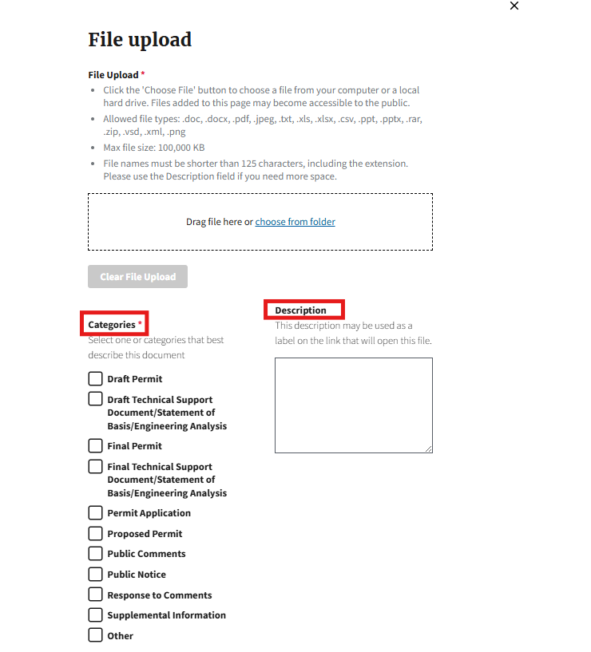
Figure 19
Once uploaded, new files will display in the “Permit Package Documents” table with a status of “Pending.” Users can delete any “Pending” files by selecting the trash can icon in the “Remove” column (Figure 20.) Users can repeat this file upload process to add additional supporting documentation to the permit action as needed.
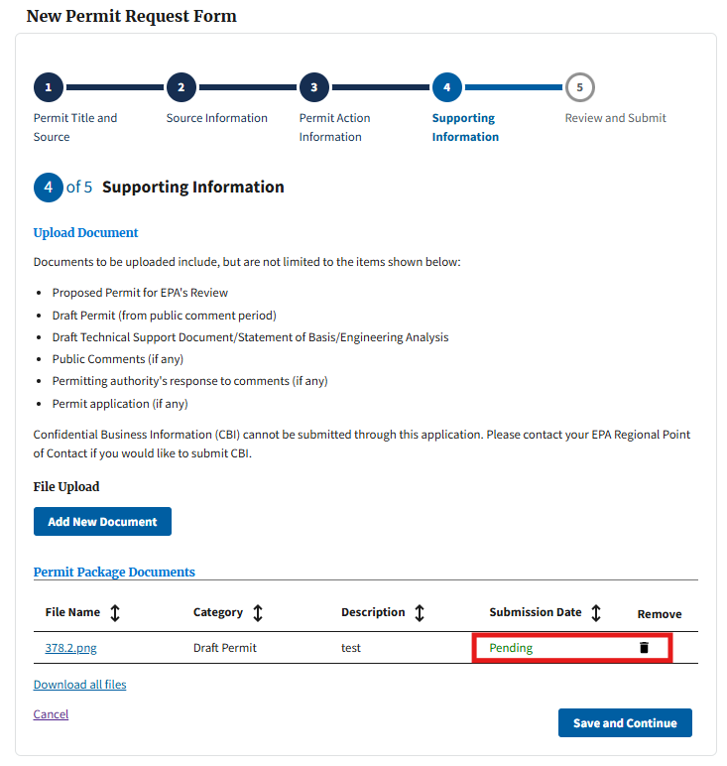
Figure 20

2.1.6 Submitting a PM Form (Permits Module)
Once all the required fields have been populated on the first four pages, proceed to page 5, “Review and Submit” by selecting “Save and Continue” at the bottom of page 4. Users can review key permit information within the “Permit Details” section as well as all files associated to the current submission within the “Permit Package Documents” table (Figure 21.)
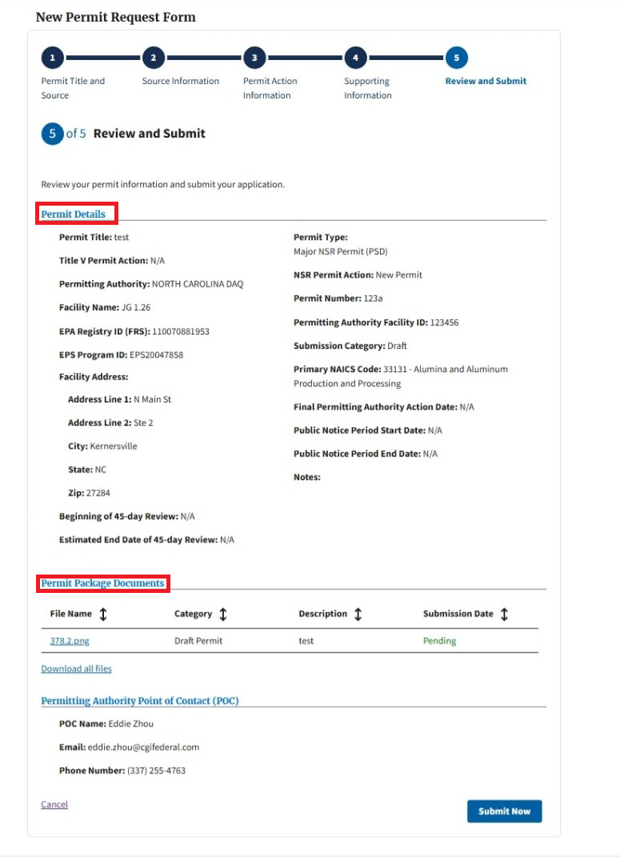
Figure 21
If users see any data they would like to edit, they can click on the text in the progress tracker (top of the form) of the respective page, to navigate to that page and make the necessary edits. Click the “Save and Continue” button on any pages that received edits. Once users verify the data is accurate on page 5, they can click the “Submit Now” button on the bottom of the page (Figure 22) to complete their PM submission. Users will then receive the confirmation submission banner at the top of the page (Figure 23.) Users will also receive an email summarizing the submission. When navigating back to the “Air Permits” table via the “Home” link on the top toolbar, the submission displays as “Submitted” in the “Status” column.
If users are submitting an applicable Final permit, navigate to Section 2.1.9 of the user guide to learn how to complete the RBLC DEM.
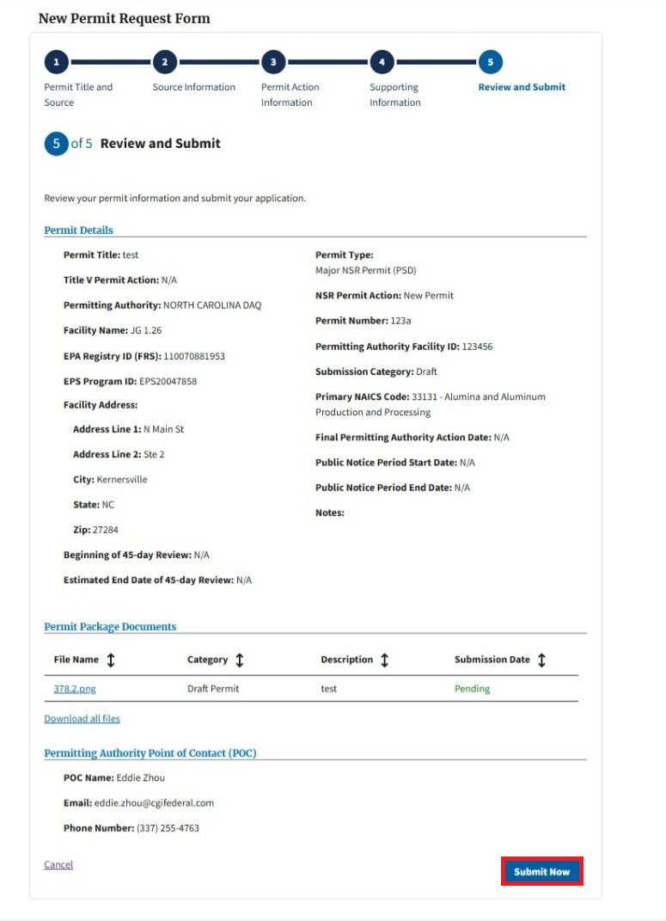
Figure 22
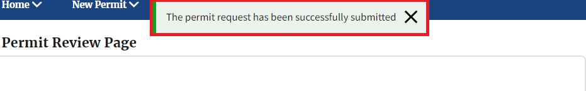
Figure 23

2.1.7 Resubmitting a PM Form (Permits Module)
If users need to resubmit a permit action (e.g., to update a permit action from proposed to final or to fix a data error), click the “Update” button in the “Air Permits” table to begin the resubmission process (Figure 24), then click the “Continue” button on the confirmation modal (Figure 25.) Resubmissions can only be performed for permit actions with a status of “Submitted” or “Resubmitted.”
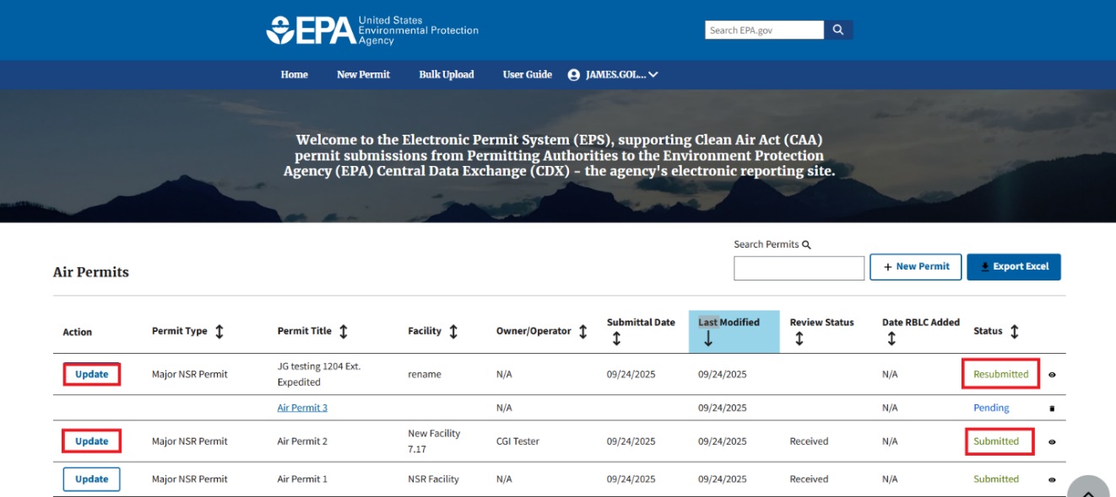
Figure 24
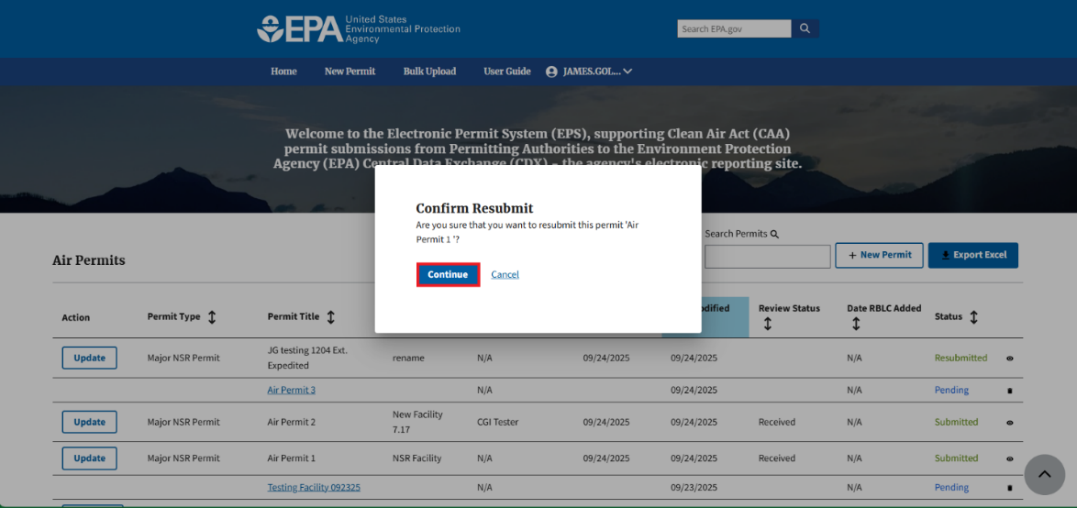
Figure 25
This reopens the previously submitted PM form for editing (Figure 26.) All data on pages 1-3 will be retained. Users can update any of the fields on these three pages as needed (e.g., change ‘Submission Category’ to “Final” on page 3, if adding the final permit.)
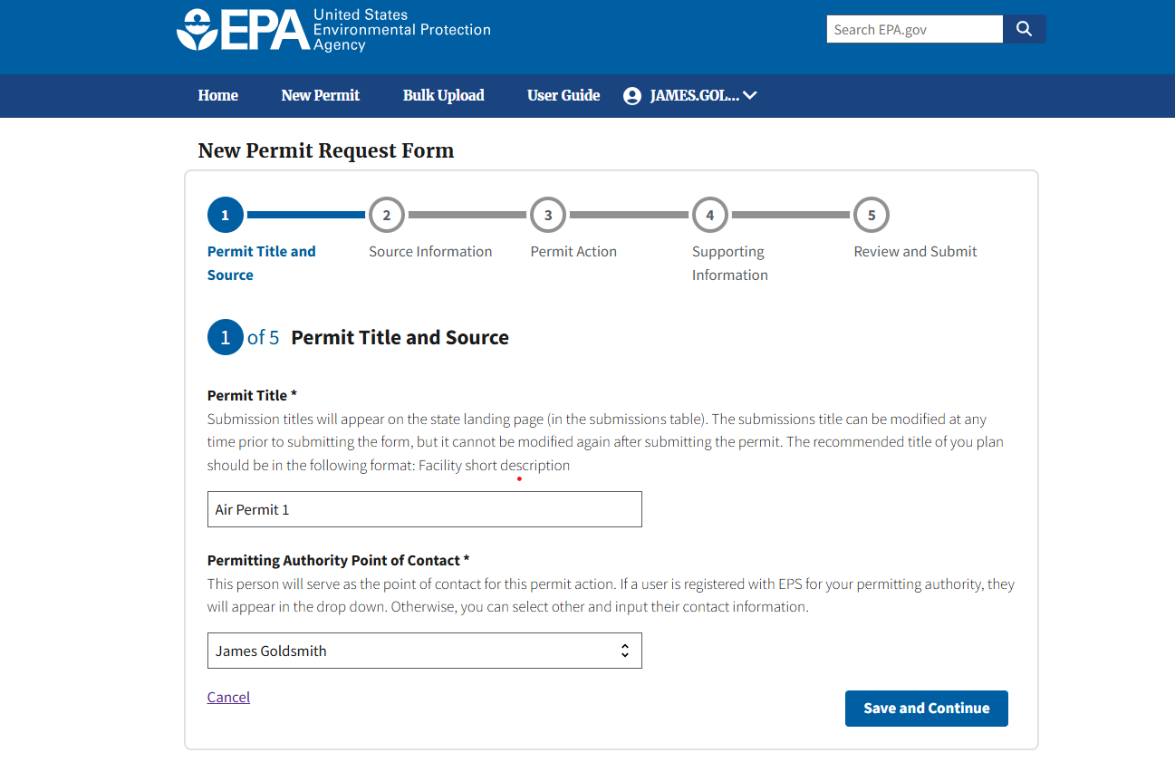
Figure 26
Documentation that was uploaded in previous permit actions will be shown in the “Permit Package Documents” table. Users may upload new documentation (e.g., the final permit) on page 4 (Figure 27), following the steps provided in Section 2.1.5.
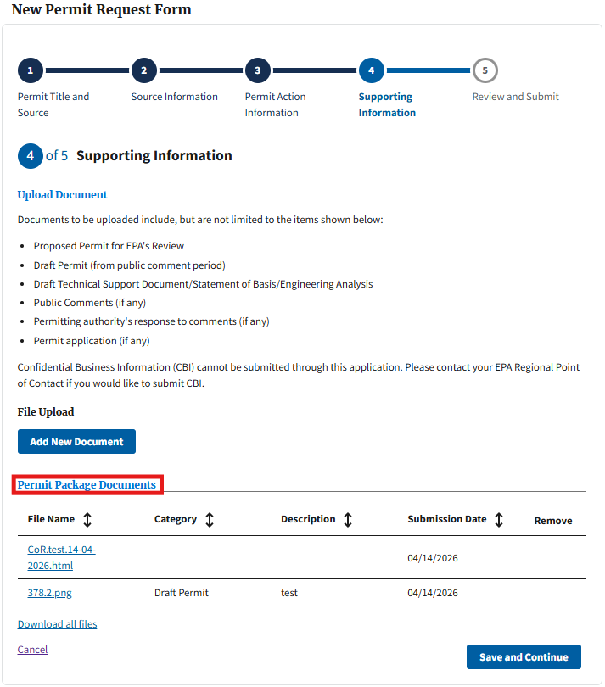
Figure 27
If at any point while editing the resubmitted permit action users need to view the “Permit Review Page" of a previous submission, click the “Home” link on the top toolbar (Figure 28) to be redirected to the “Air Permits” table. The permit action will display a status of “Revision In Progress” in the “Status” column. Clicking the “Review Previous” button in the “Action” column of the table (Figure 29) redirects users to the most recent submission’s “Permit Review Page” in a new window.
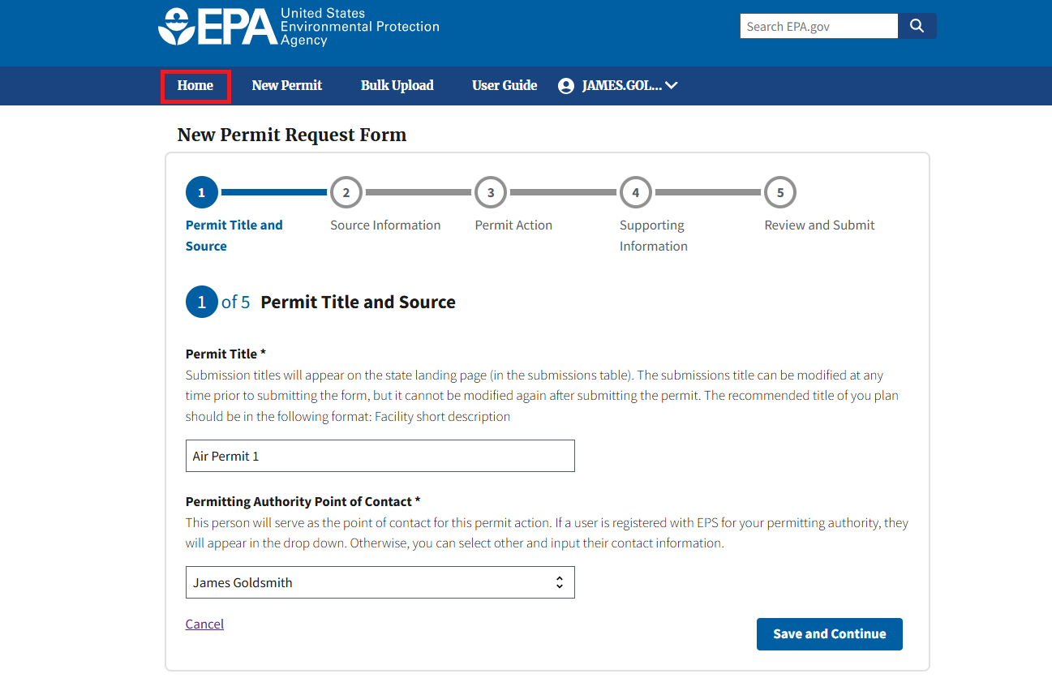
Figure 28
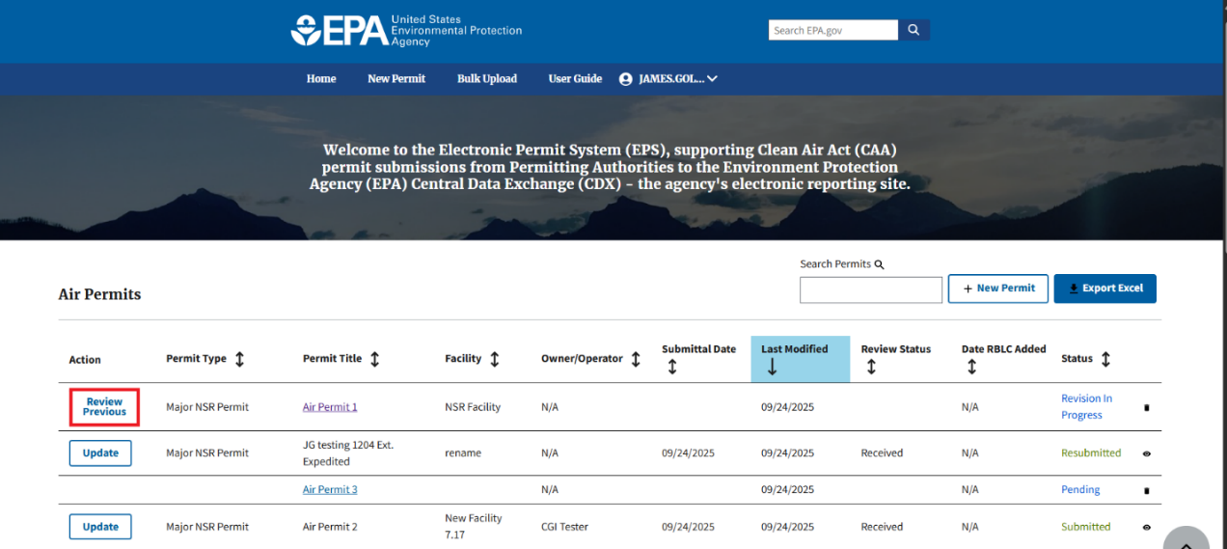
Figure 29

Once users have updated their permit action and completed the resubmission process by selecting “Submit Now” on the “Review and Submit” page, both the resubmitted and original permit action become part of the same “Permit Package.” Users can resubmit a permit action multiple times, and there is no limit to the number of resubmissions for a given action. Every resubmission made during the permit’s lifecycle are linked together as a part of the same “Permit Package.” Users can view all documentation associated to the Permit Package in the “Permit Package Documents” table on the “Permit Review Page.” When navigating back to the “Air Permits” table, the submission displays as “Resubmitted” in the “Status” column (Figure 30.) Once a PM form is resubmitted, only the data associated with the most recent permit action in the package is displayed on the “Air Permits” table.
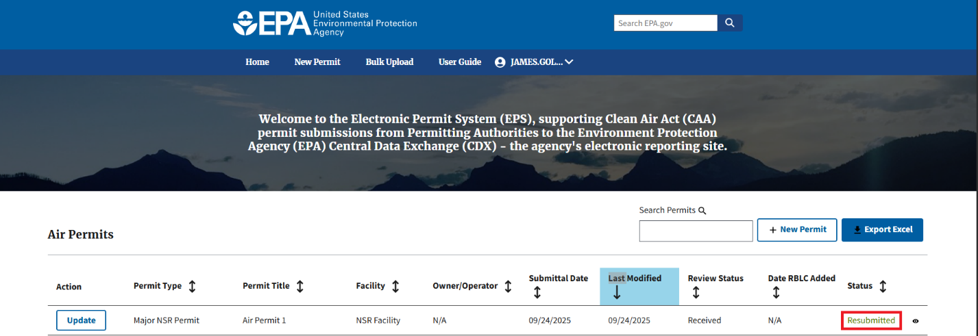
Figure 30

2.1.8 Accessing the Permit Review Page
Click the eye icon (Figure 31) in the “Air Permits” table for a given permit action to navigate to that permit’s “Permit Review Page”. This option is only available for permit actions with a status of “Submitted” or “Resubmitted.”
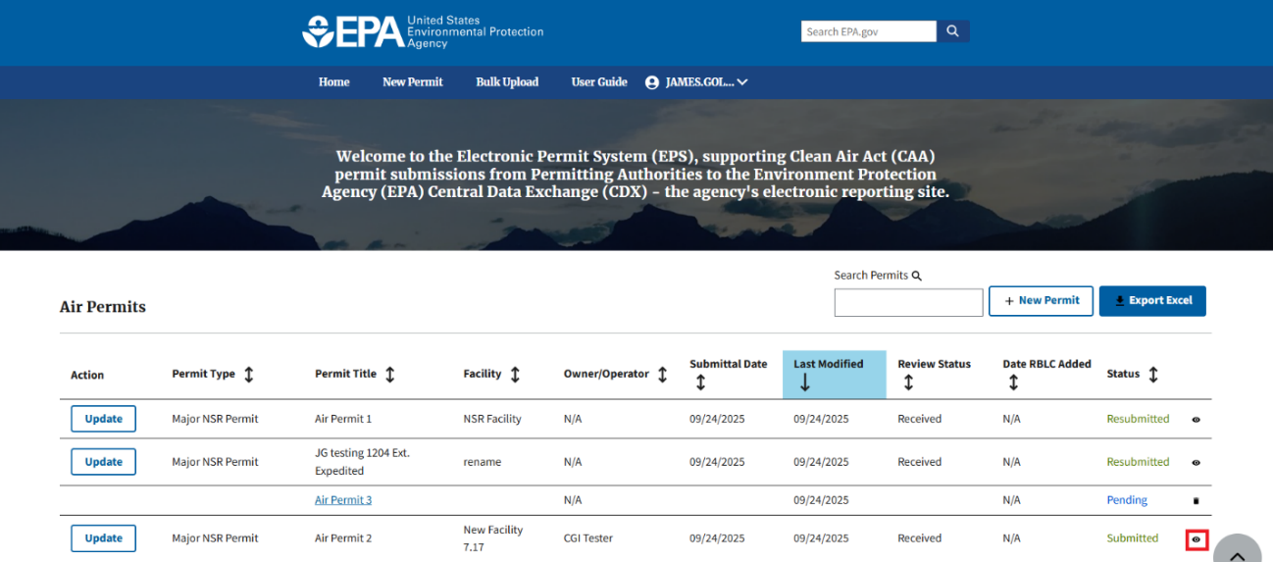
Figure 31
Users can view the permit details, permit review status, and the date EPA completed the review of the most recent permit action in the Permit Package. Comments from EPA, the EPA Point of Contact (POC), and documentation provided from EPA (“EPA Shared Files” table) will all be displayed, regardless of which permit action in the Permit Package the data is associated with (Figure 32.)
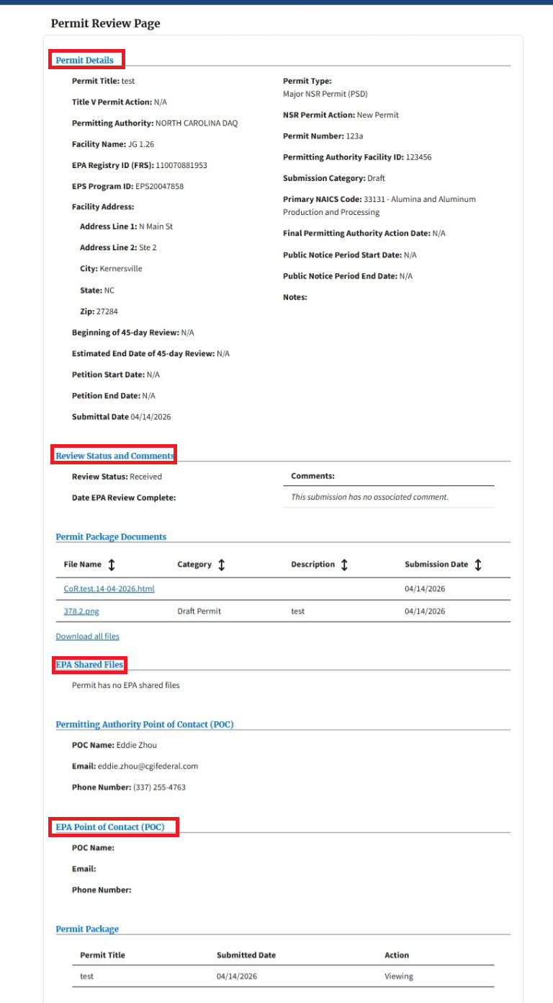
Figure 32

The “Permit Package Documents” table allows users to download documentation that was uploaded by the PAP user as part of the Permit Package, as well as the Copy of Record from each submission made in the Permit Package (Figure 33.)
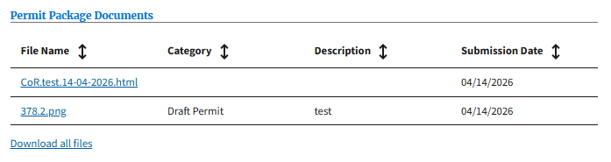
Figure 33
The “Permit Package” table at the bottom of the page displays all permit actions within the Permit Package, as well as the date they were submitted. Users can click the links within the “Action” column to view any permit action within the package. If there is only one permit in the package, there will only be one row in the table (Figure 34.)
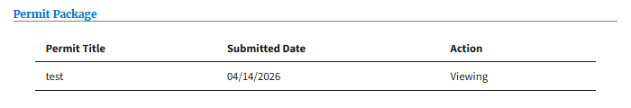
Figure 34

2.1.9 Navigating to the RACT/BACT/LAER Clearinghouse (RBLC) Data Entry Module (DEM)
After submitting a permit action with a “Submission Category” of “Final”, users with applicable permits (see note below) should navigate to the RBLC DEM to begin entering their RBLC information for the corresponding permit/facility, in one of three ways:
- Click the “Add RBLC Data” button in the “Date RBLC Added” column in the “Air Permits” table (Figure 35.)
- Click the link in the banner at the top of the “Permit Review Page” (Figure 36.)
- Click the “+RBLC” button under the “RBLC Data” section on the “Permit Review Page” (Figure 36.)

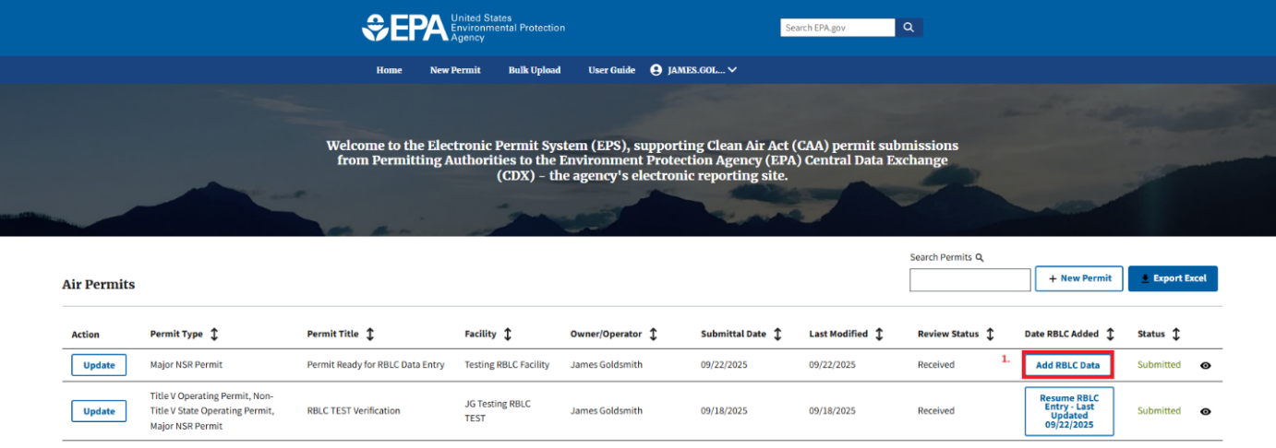
Figure 35
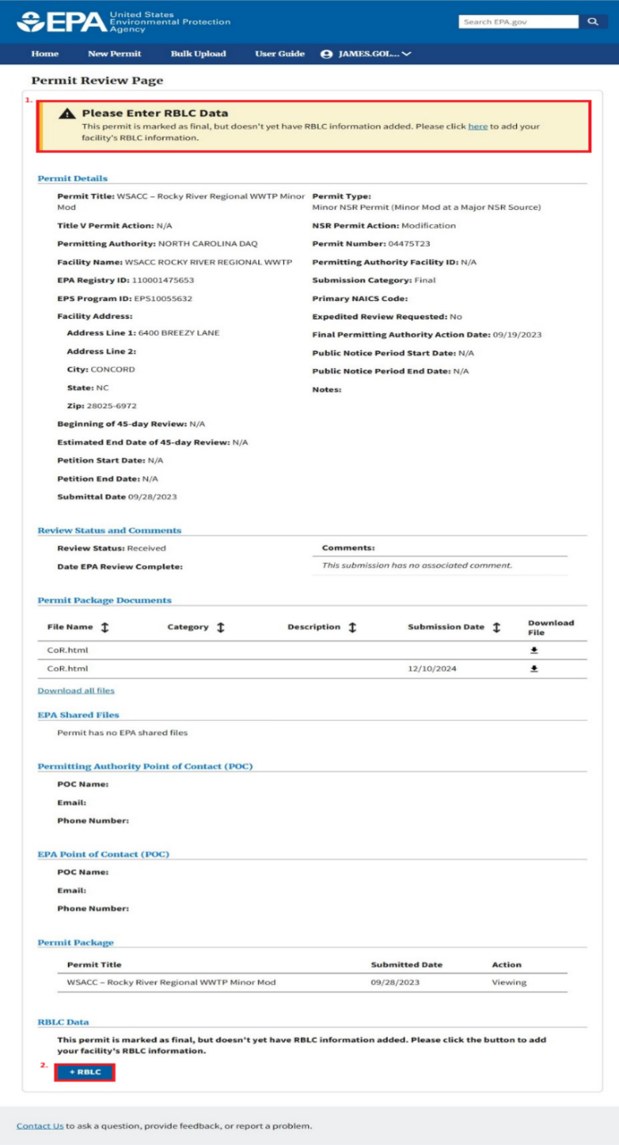
Figure 36
If at any point during the RBLC data entry process, users save and leave their DEF in an in-progress state, they will be able to navigate back to their in-progress DEM form in one of three ways:
- Click the “Resume RBLC Entry – Last Updated MM/DD/YYYY” button in the “Date RBLC Added” column on the “Air Permits” table.
- Click the “Finish RBLC Data” button under the “RBLC Data” section of the “Permit Review Page.”
- Click the “here” link in the banner at the top of the “Permit Review Page”.
Note: At this time, final permit actions that are Title V Operating Permits (OPs), Minor New Source Review (NSR): General Permits (GPs), or permits with the “General Permit (GP)or Not Source Specific” checkbox selected on the “Source Information” page, do not have the capability to report RBLC information in the RBLC DEM. If a user’s permit is not eligible for RBLC data entry, the “RBLC Date Added” column of the “Air Permits” table will display as “N/A” (Figure 37.) The number of permit types that are eligible for RBLC data entry will likely increase in the future.
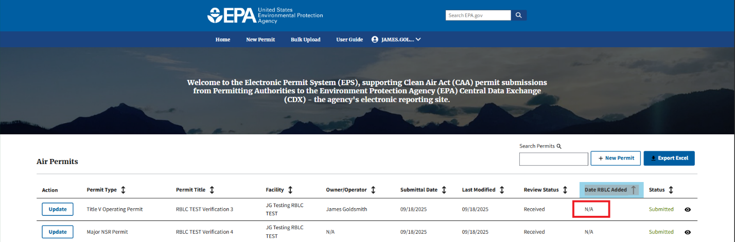
Figure 37
Proceed to Section 3.0 RBLC DEM for information on how to enter and submit RBLC data.

2.2 RBLC Permitting Authority Preparer Users
RBLC-PAP users utilize the PM in a more streamlined capacity than PAP users. The PM for RBLC-PAP users contain a workflow that is restricted to preparing and submitting Final permit data solely for RBLC DEM data entry purposes. RBLC-PAP users create permit actions by completing a subset of data entry fields across multiple pages, but unlike PAP users they cannot upload supporting documents in the PM and do not participate in EPA review cycles. All PM submissions for these users are automatically categorized as “Final,” and certain permit types (e.g., Minor NSR: GPs and Title V OPs that are not combined with an NSR permit action) are unavailable for selection. Once users submit through the PM, RBLC-PAP users are immediately routed into the RBLC DEM to complete RBLC data entry.
The subsequent sub-sections provide a walk-through of the user interface.

2.2.1 Navigating the Permitting Authority Landing Page
The “Permitting Authority Landing” (PAL) page, “Air Permits” table houses all pending and submitted permit actions for a given PA. Permit actions submitted to EPA have a value of either “Permit Submitted” or “RBLC Submitted” in the “Status” column. “Permit Submitted” indicates that the RBLC-PAP user has submitted their PM form. “RBLC Submitted” indicates that the RBLC-PAP user has submitted their PM form as well as their DEM Form (DEF). For more information on the RBLC DEM see section 3.0.
Pending permit actions that are still being worked on have a status of “Pending” in the “Status” column. The table also allows users to (1) sort, (2) search, and (3) export data to an Excel .xlsx file (Figure 38.)
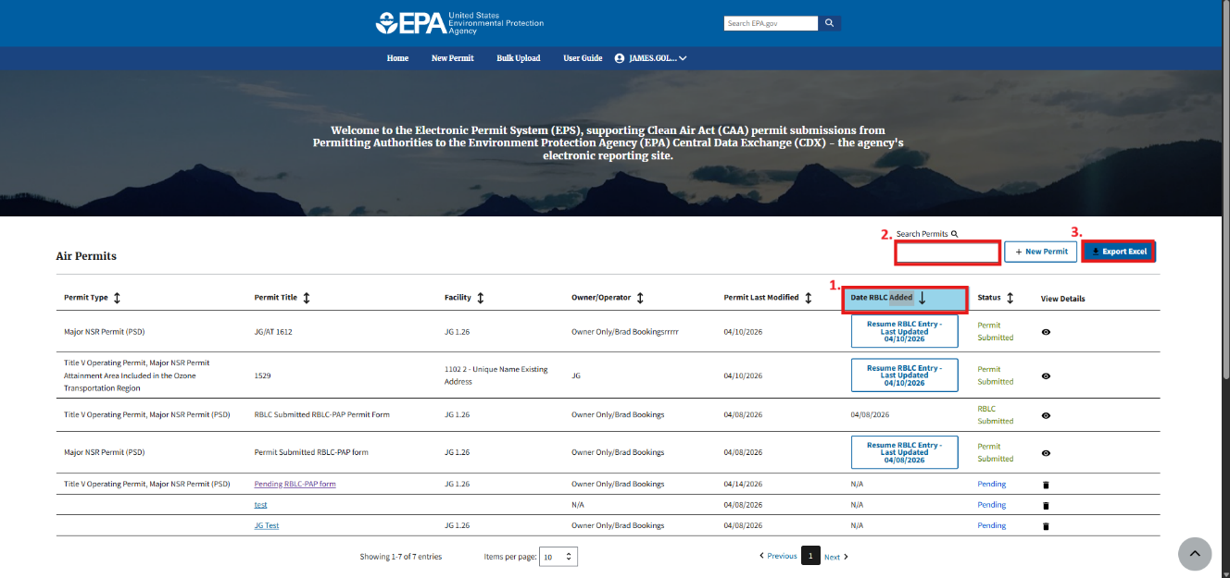
Figure 38
Users can click the “Permit Title” hyperlink for permit actions with a “Pending” status to be redirected to the in-progress PM form within the PM. There, users can finish data entry and submit their permit action. Additionally, users can delete “Pending” permit actions by selecting the trash icon in the “View Details” column (Figure 39.)
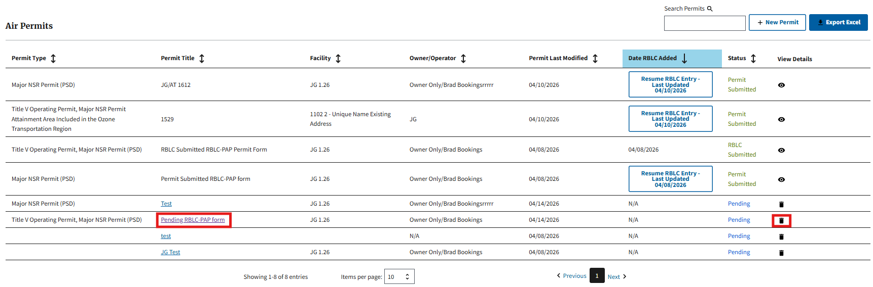
Figure 39
To find additional information on permit actions with a “RBLC submitted” status, navigate to Section 3.3 of the user guide.

2.2.2 Creating a New PM Form (Permits Module)
Clicking the “+ New Permit” button on the top right corner of the “Air Permits” table or clicking the “New Permit” tool bar link redirects users to a new permit action. From there, users can begin data entry (Figure 40.)
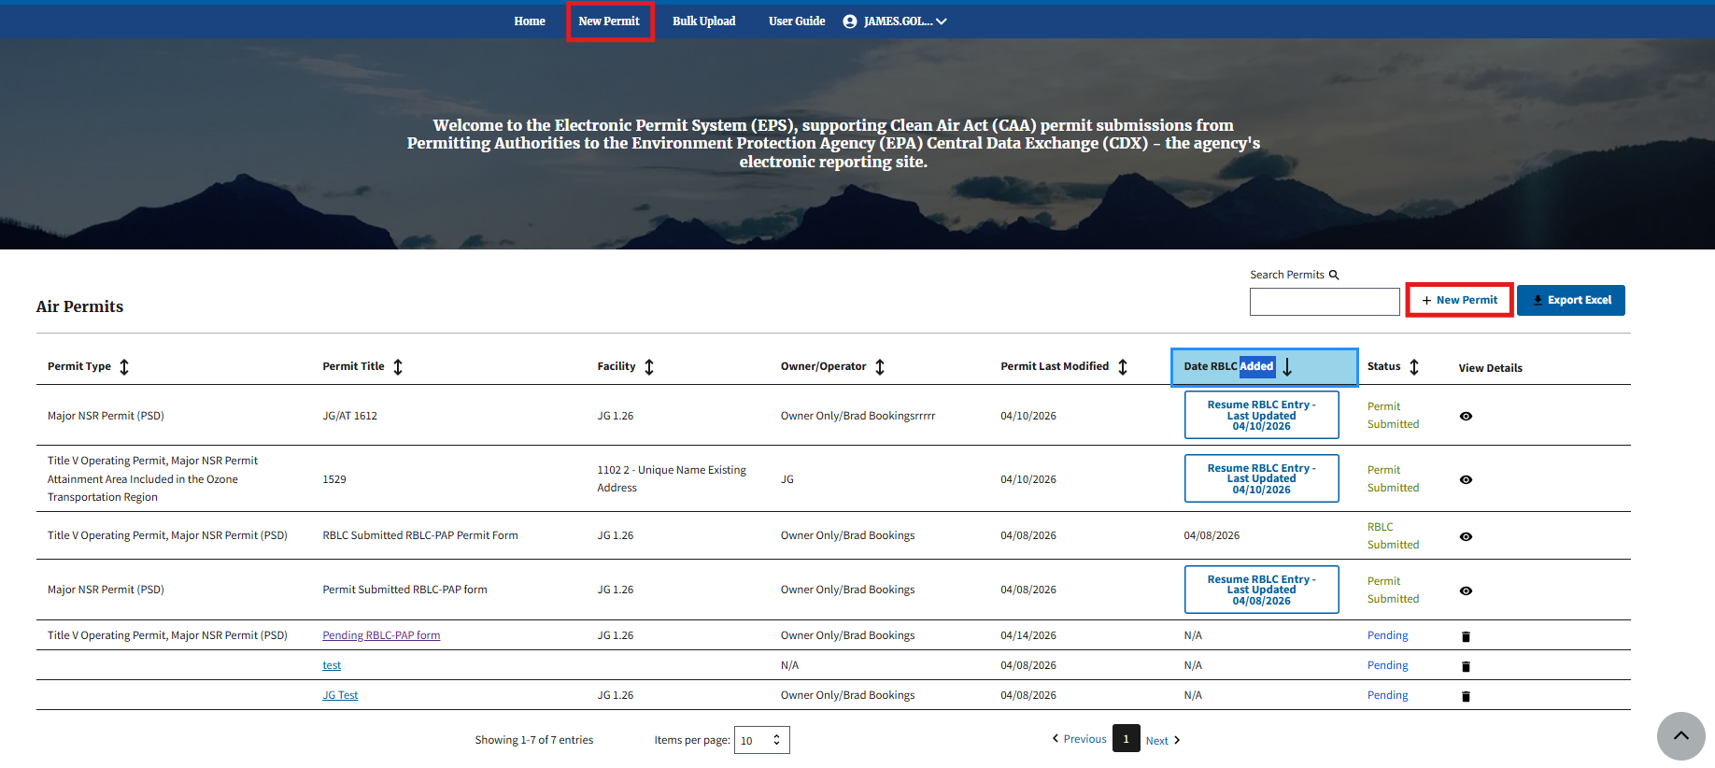
Figure 40

2.2.3 PM Form Data Entry (Permits Module)
Once users have initiated a new permit action, users can add information to the following pages of the form:

- Permit Title and Source
- Source Information
- Permit Action Information
After users complete all required fields on page 1, click the “Save and Continue” button to navigate to the next page within the form (Figure 41.) Users cannot navigate throughout the form until page 1 is saved. If at any point while entering data for the permit action users need to save and come back later, click the “Home” link on the top toolbar to be redirected to the “Air Permits” table. The permit action will display a status of “Pending” in the “Status” column.

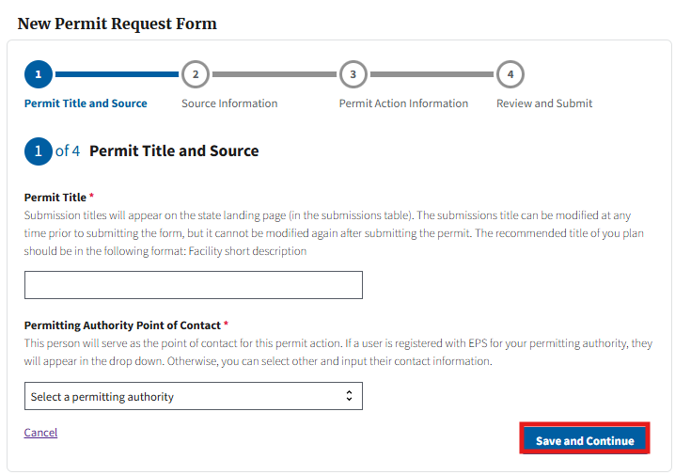
Figure 41

2.2.4 Linking Existing Facilities (Permits Module)
After completing the fields on the first page, users will proceed to the “Source Information” page where users are able to link their permit action to a facility (Figure 42.)
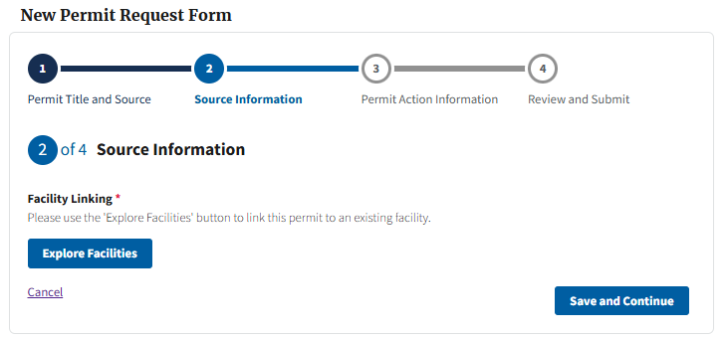
Figure 42
Click the “Explore Facilities” button (Figure 43) to open the “Explore Facilities” modal. Users can search for facilities previously used in CAAPS via Zone Improvement Plan (ZIP) code. Additionally, if users are searching for an existing “Mobile” or “Offshore” facility, users can do so using the corresponding checkboxes (Figure 44.)
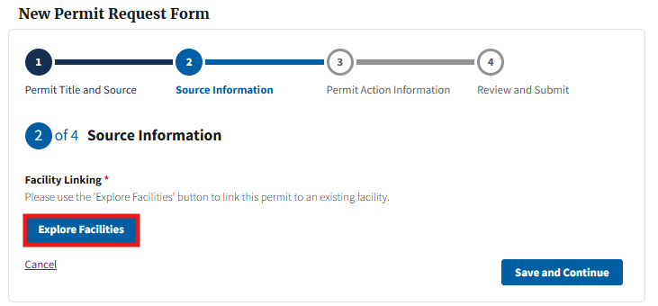
Figure 43
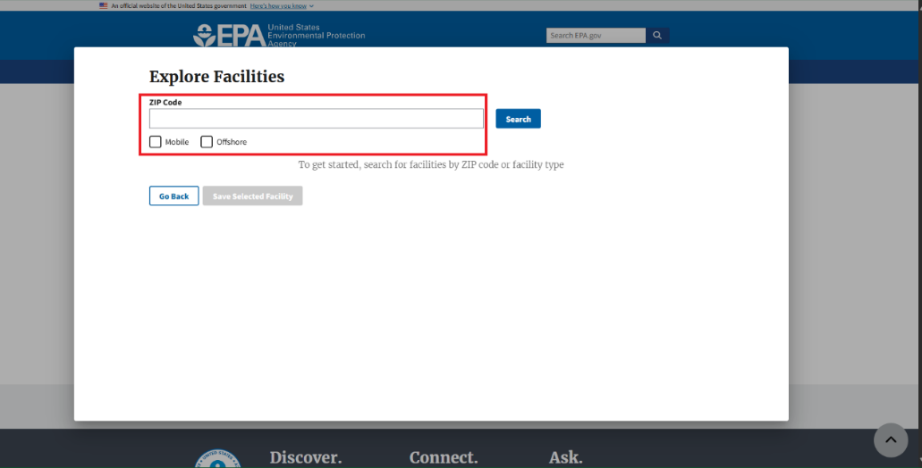
Figure 44
Once users enter the needed ZIP code or select one of the “Mobile” or “Offshore” options, click the “Search” button to return facilities matching the search parameters (Figure 45.) Users can select the appropriate facility and then click the “Save Selected Facility” button to link the facility to their permit action (Figure 46.)

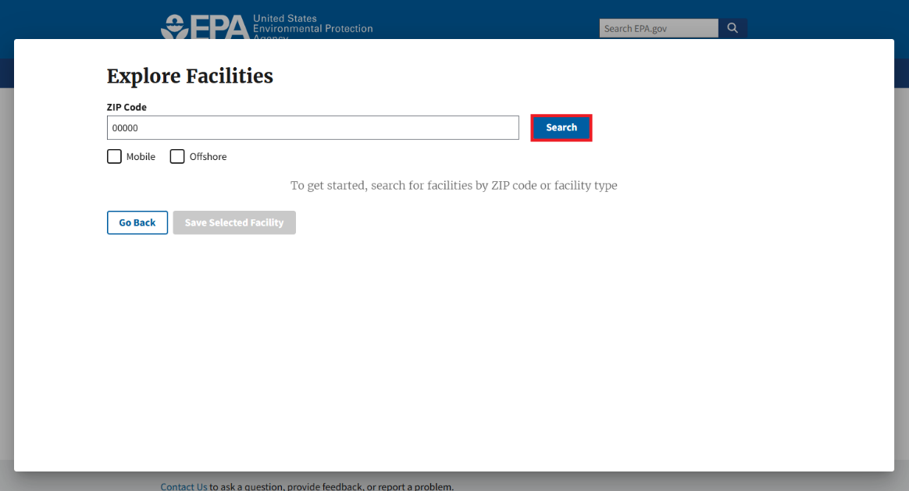
Figure 45
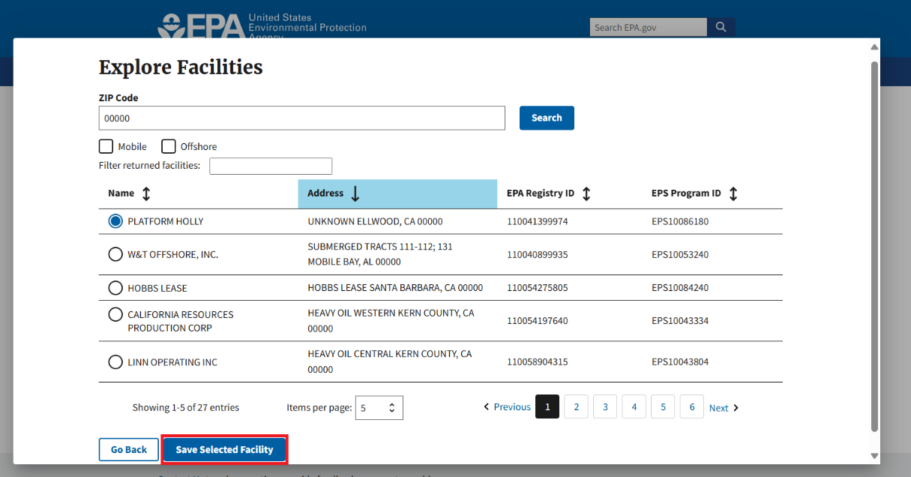
Figure 46
After clicking the “Save Selected Facility” button, users are taken back to the “Source Information” page where the selected facility’s data is now prepopulated (Figure 47.)
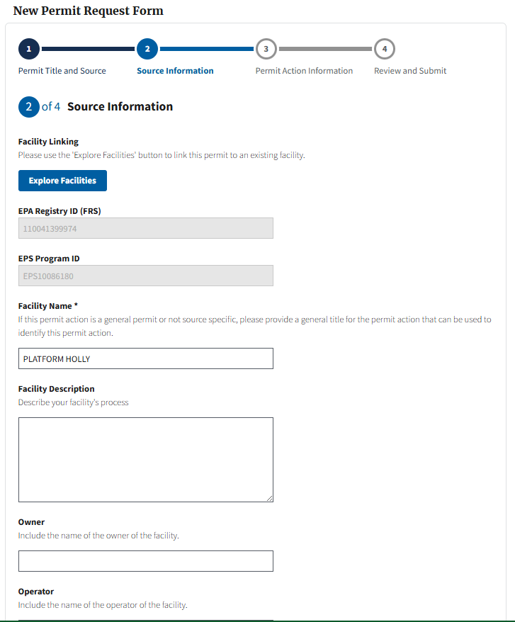
Figure 47
Users can make any necessary changes to the associated facility data on this page. Once the permit action is submitted, any updates to the facility are then applied to that facility’s record and will show on future permit actions that use the same facility. Permit actions associated with that facility that were submitted prior to their updates will maintain the same facility data that was associated with the facility at the time of their prior submission.
If users cannot find their facility or need to create a new facility, click the “Search” button and then click “here” at the bottom of the screen to complete manual data entry of the facility related fields on the “Source Information” page (Figure 48.) Once submitted, the new facility will be available to search via ZIP code for any future user that needs to submit on behalf of the facility.
Figure 48
Regardless of whether a user is linking to a facility or creating a new facility, users must select the “Verify Address” button before being able to “Save and Continue” on the “Source Information” page (Figure 49.)
Figure 49
Once “Verify Address” is selected, users will receive a modal with address suggestions based on the facility address data provided. If the service provides a match, users can select the suggested address to automatically fill in the remaining address data fields for the facility. Users can select “Close” to elect not to use the suggested address candidates returned and continue manually entering the remaining facility data (Figure 50.)
Figure 50
Note: RBLC-PAP users will not be required to enter mailing address data within the “Source Information” page. Additionally, RBLC-PAP users will also not be able to submit permit data on behalf of “General or Not Source Specific” facilities.

2.2.5 Entering Final Permit Data (Permits Module)
After completing the fields on the “Source Information” page, users will proceed to the “Permit Action Information” page to enter critical permit data for the submission such as permit number, permit type, and date fields that may have taken place during the permitting lifecycle outside of CAAPS (Figure 51.)
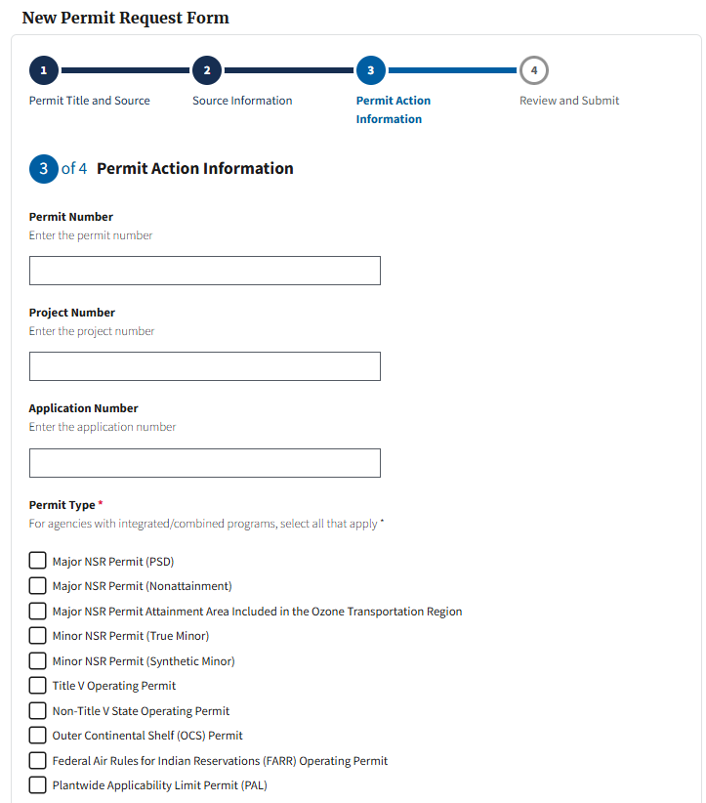
Figure 51
RBLC-PAP users will not be able to select a “Submission Category” for their submission as all RBLC-PAP PM submissions will be defaulted to “Final.” Additionally, all RBLC-PAP users are required to enter the “Final Permitting Authority Action Date” on the “Permit Action Information” page to signify when the permit data was finalized outside of CAAPS.
RBLC-PAP users are unable to select the Minor NSR: General Permit “Permit Type” option as this type of permit is not eligible for RBLC data entry. Additionally, user’s will not be able to select “Title V OP” unless the selection is combined with an NSR “Permit Type.”

2.2.6 Submitting a PM Form (Permits Module)
Once all the required fields have been populated on the first three pages, proceed to page 4, “Review and Submit” by selecting “Save and Continue” at the bottom of page 3. Users can review key permit information on this page (Figure 52.) If users see any data users would like to edit, they can click on the text in the progress tracker (top of the form) of the respective page, to navigate to that page and make the necessary edits. Click the “Save and Continue” button on any pages that received edits.
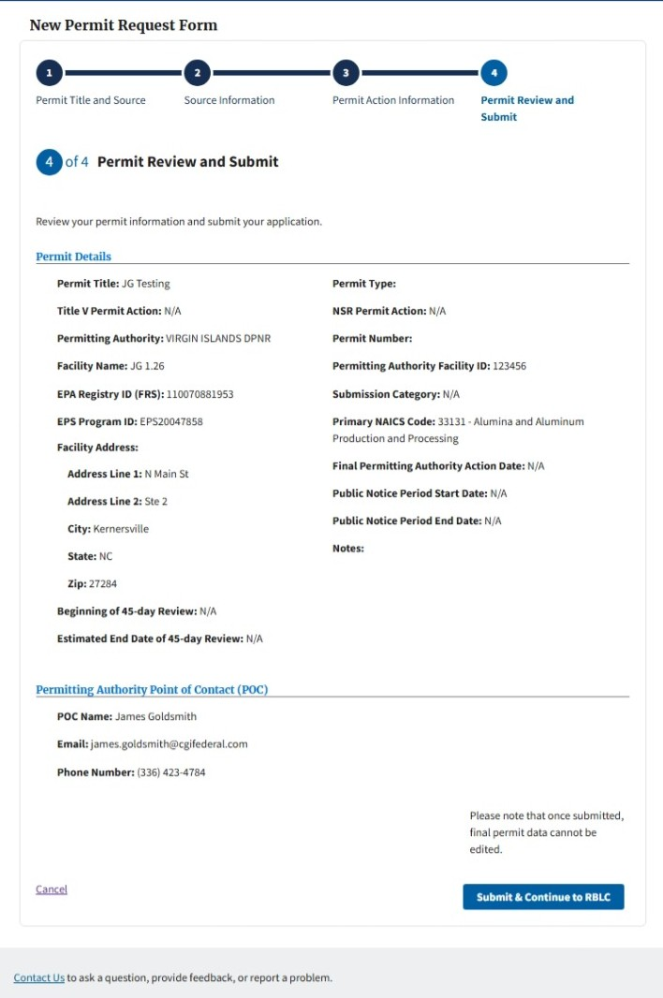
Figure 52

Once users verify the data is accurate on page 4, they can click the “Submit & Continue to RBLC” button on the bottom of the page to complete their PM submission (Figure 53.) Users will then be redirected immediately to the RBLC DEM to complete their DEM form. Users will also receive an email summarizing the PM submission.
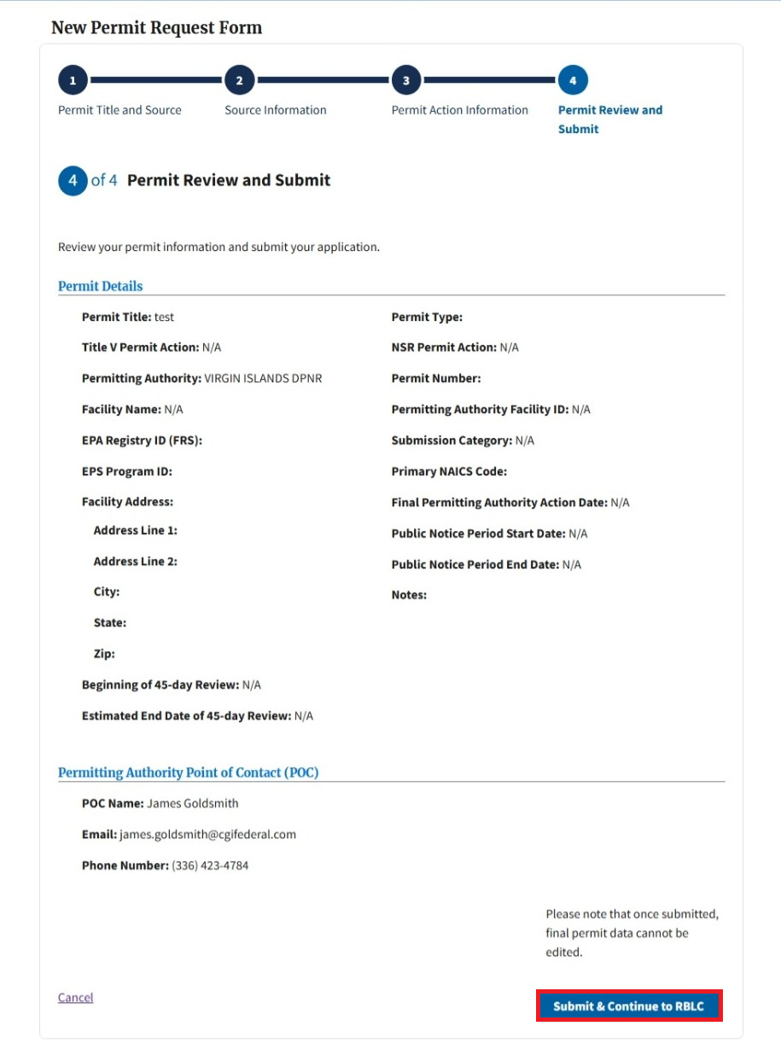
Figure 53
Navigate to Section 3.0 of the user guide to learn how to complete the RBLC DEM.

2.2.7 Accessing the Permit Review Page
Click the eye icon (Figure 54) in the “Air Permits” table for a permit action to navigate to that permit’s “Permit Review Page.” This option is only available for permit actions with a status of “Permit Submitted” or “RBLC Submitted.”
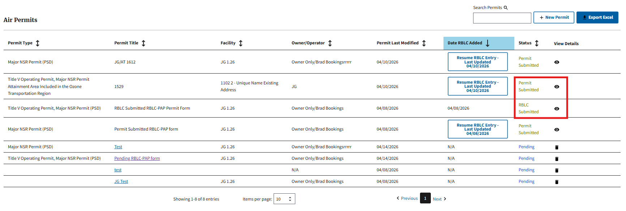
Figure 54
For permit actions with a status of “Permit Submitted” and “RBLC Submitted,” users can view the permit details on the “Permit Review Page” (Figure 55.) EPA will not be able to provide permit reviews on PM submissions made by RBLC-PAP users, however, EPA will have the ability to update the “Beginning of 45-day Review” date, if applicable. If EPA does alter these dates, RBLC-PAP users will be able to view any changes on the “Permit Review Page” and be notified via email.
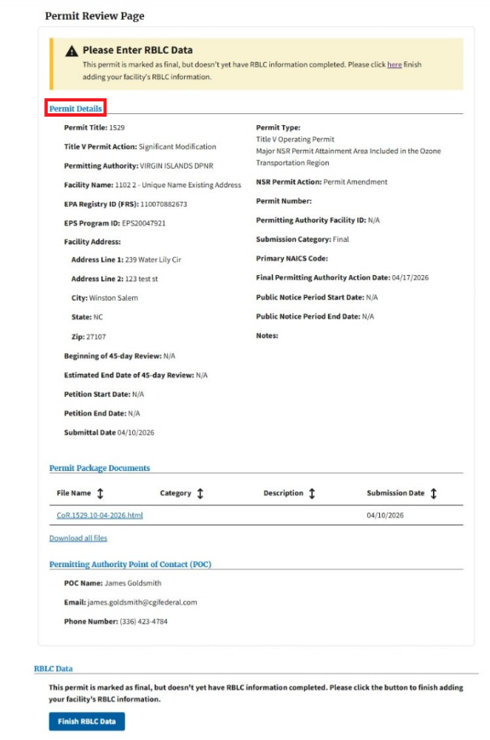
Figure 55

2.2.8 Navigating to the RACT/BACT/LAER Clearinghouse (RBLC) Data Entry Module (DEM)
After selecting the “Submit & Continue to RBLC” button on the “Review and Submit” page of the PM, users will be navigated directly to the RBLC DEM to begin entering their RBLC information for the corresponding permit/facility. Additionally, users can navigate to the RBLC DEM to begin entering their RBLC information for the corresponding permit/facility, in one of three ways.
- Click the “Add RBLC Data” button in the “Date RBLC Added” column on the “Air Permits” table (Figure 56.)
- Click the link in the banner at the top of the “Permit Review Page (Figure 57.)
- Click the “+RBLC button under the “RBLC Data” section on the “Permit Review Page” (Figure 57.)
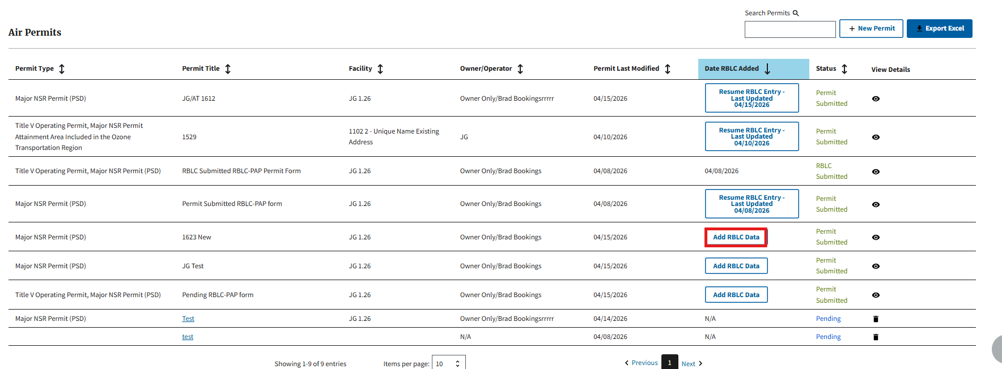
Figure 56
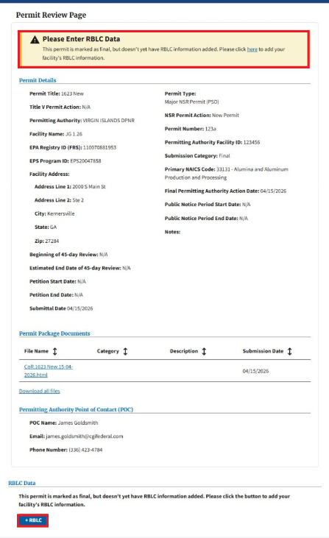
Figure 57
If at any point during the RBLC data entry process, users save and leave their Data Entry Form (DEF) in an in-progress state, they will be able to navigate back to their in-progress DEM form in one of three ways:
- Click the “Resume RBLC Entry – Last Updated MM/DD/YYYY” button in the “Date RBLC Added” column on the “Air Permits” table.
- Click the “Finish RBLC Data” button under the “RBLC Data” section of the “Permit Review Page.”
- Click the “here” link in the banner at the top of the “Permit Review Page.”

Proceed to Section 3.0 RBLC Data Entry Module (RBLC DEM) for information on how to enter and submit RBLC data.

3.0 RBLC Data Entry Module (RBLC DEM)
The RBLC DEM gives SLT agency users the opportunity to input their RBLC information. All RBLC data entries must occur after a final permit is issued because the entries need to reflect the air pollution control technology requirements that are included in the final permit. After RBLC data is submitted via the DEM, it will be made available within the RBLC Search Dashboard. The RBLC Search Dashboard was designed to help permit applications and reviewers search for and review all pollution prevention and control technology decisions, enabling them to make decisions for stationary air pollution sources. The RBLC DEM is nearly identical for both user (RBLC-PAP and PAP) groups.

3.1 RACT/BACT/LAER Information DEF
Once users have navigated to the RBLC DEM, users will add control technology data within the following sections (Figure 58 & Figure 59):
- Process
- Unit
- Pollutants
- Emission Limits
- Control Method
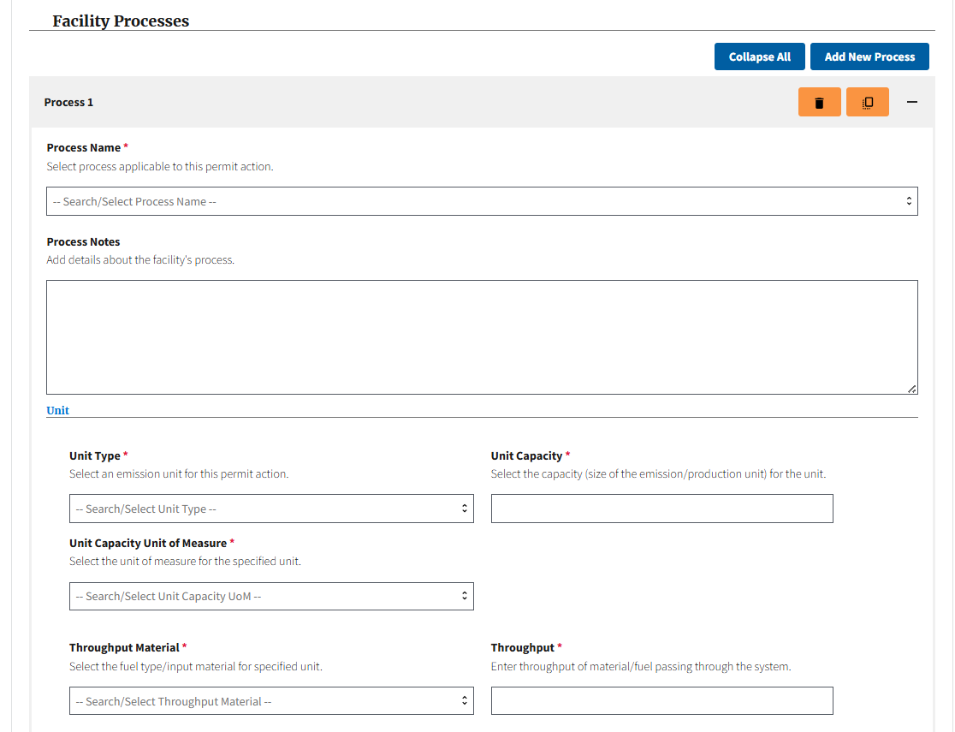
Figure 58

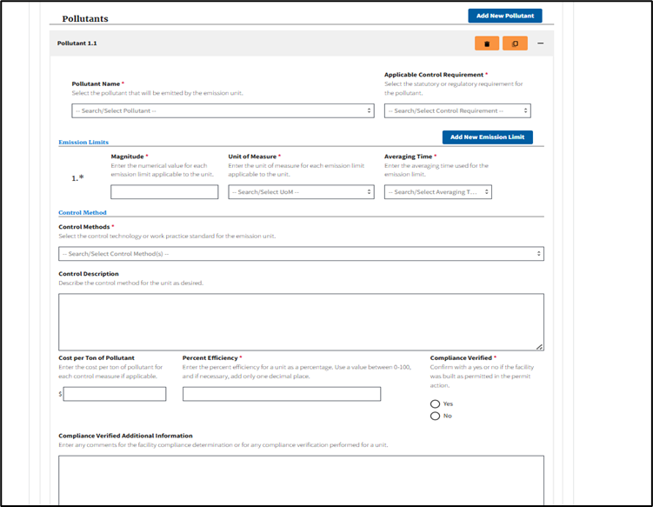
Figure 59
The data is organized so that multiple processes may be added where each process has capacity and throughput data, and can have one or many pollutants, with underlying emission limit and control method data. To add a new “Process,” “Pollutant,” or “Emission Limit” to their DEM form, click the “Add New Process,” “Add New Pollutant,” and/or “Add New Emission Limit” buttons (Figure 60 & Figure 61.)
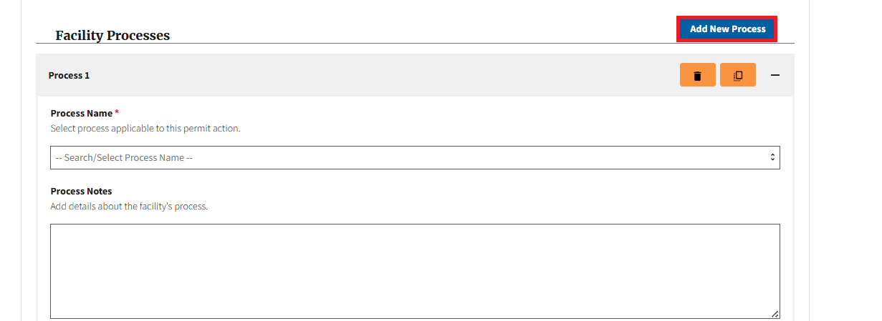
Figure 60
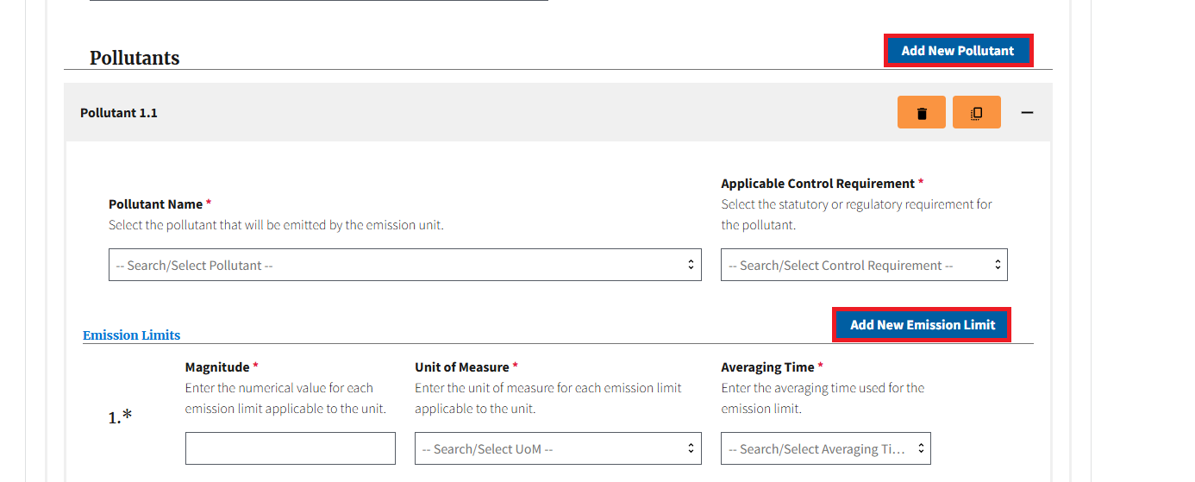
Figure 61
If multiple pollutants or processes have been entered within the DEM form, users can collapse or expand a single process or pollutant by selecting the “-” or “+” buttons in the header of the selected pollutant or process (Figure 62.) Additionally, users can select the “Collapse All” or “Expand All” button to collapse or expand all processes and/or pollutants entered within the DEM form (Figure 63.)
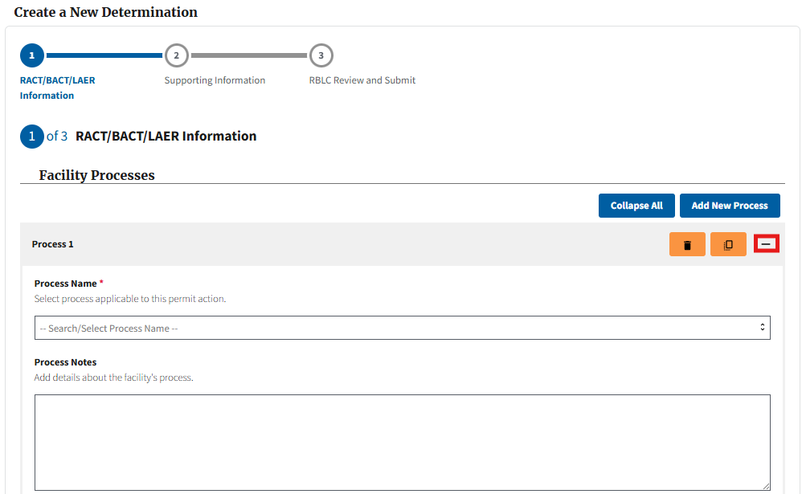
Figure 62
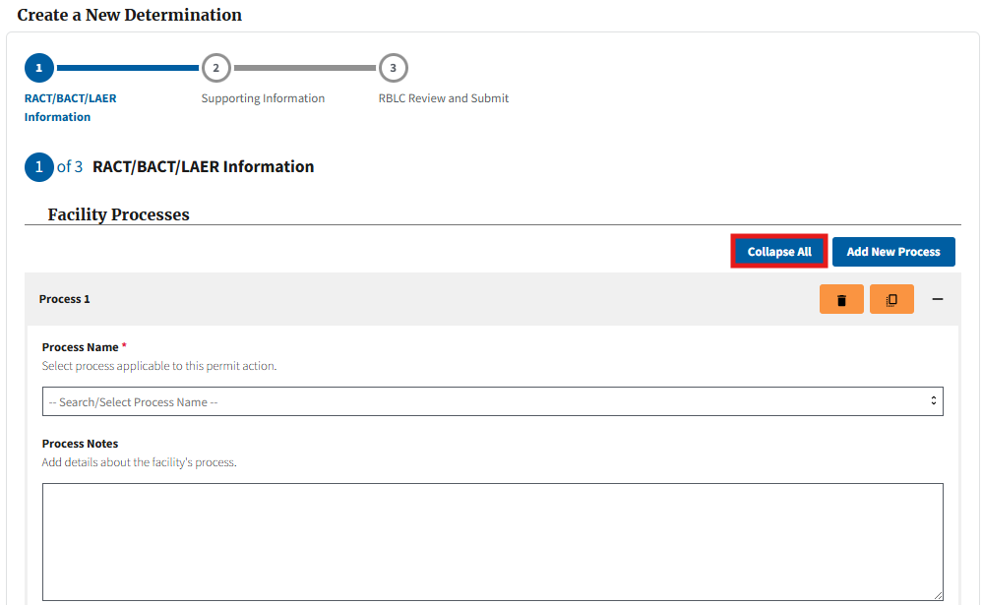
Figure 63
Users also can delete or duplicate, completed processes and pollutants by using the buttons located in the accordion within the DEM form (Figure 64 & Figure 65.) The “Duplicate” button can be used when users have multiple processes that are similar. This will copy the underlying data into a new process, shown at the bottom of their screen, where users can then edit underlying data, as needed. Users can also duplicate pollutant data, however, users can only duplicate pollutants within the same process.
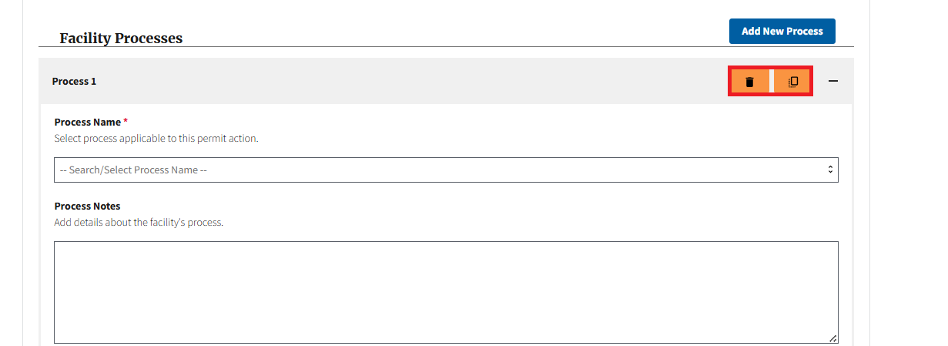
Figure 64
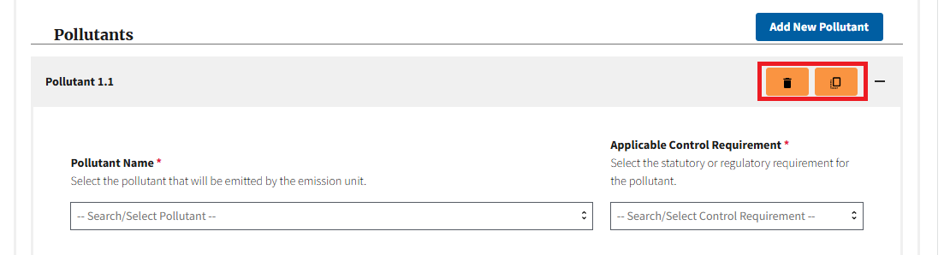
Figure 65

3.2 Uploading Supporting Documentation
After completing all fields on the first page, users can proceed to the “Supporting Information” page where they can upload all supporting documentation related to the submission. Users can add as many supporting documents as needed on the “Supporting Information” page (Figure 66.)
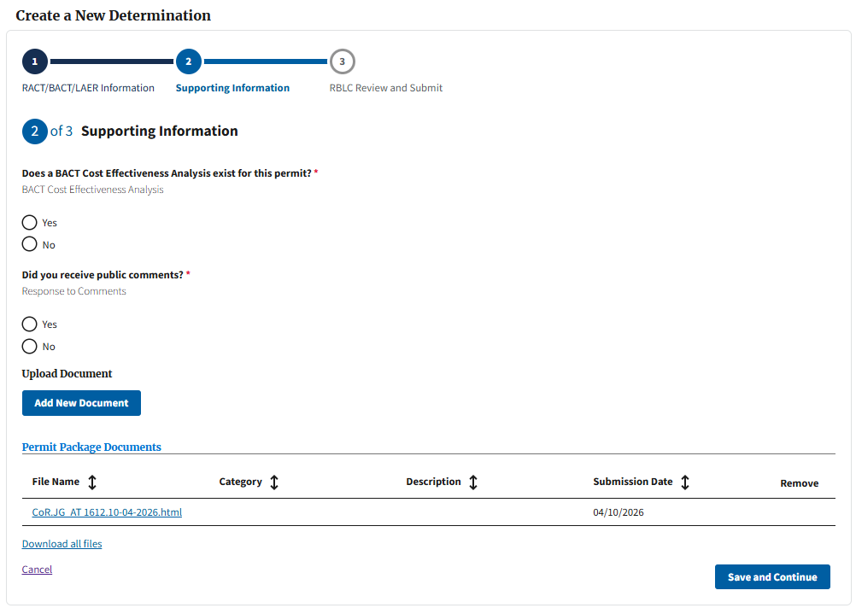
Figure 66
Click “Add New Document” to open the File Upload modal (Figure 67.)
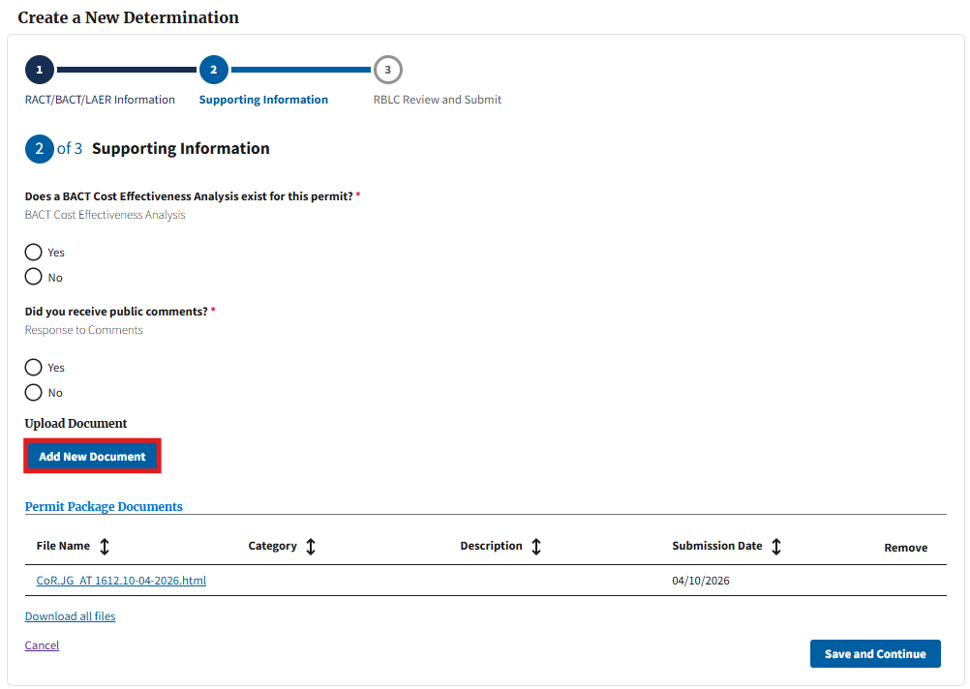
Figure 67
A list of the supported file types is provided on the modal. Users can either drag and drop any supported file type or click the “Choose from Folder” button to choose a file from their local hard drive. Users are required to assign uploaded files at least one, but can choose multiple, document category via the “Categories” field to help EPA better determine what each attachment represents. Users can also add a description to each file, if further details are needed (Figure 68.) Once a document category and description are added, users can select “Upload” to add the document to their DEM form.
Figure 68
All users in the RBLC DEM will be required to upload the (bulleted list) below documents. The documents can all be in the same file (e.g., ZIP file) or in separate files. Prior to saving and continuing to the final page, users must ensure they have selected checkboxes for the following document categories:
- Permit Application
- Draft Permit
- Final Permit
- Final Technical Support Document/Statement of Basis/Engineering Analysis
On this page, users will be asked “Did you receive public comments?” (Figure 69.) If yes, users will be required to select the “Response to Comments” document category to at least one document upload before being able to submit their RBLC DEM form.

Figure 69
Additionally, if users selected “Best Available Control Technology” (“BACT”) in the “Applicable Control Requirement” field for at least one pollutant on the “RACT/BACT/LAER Information” page, users will be asked “Does a BACT Cost Effectiveness Analysis exist for this permit?” (Figure 70.) If yes, users will be required to add the “BACT Cost Effectiveness Analysis (CBI Redacted)” document category for at least one file upload before being able to save or submit their RBLC DEM form.
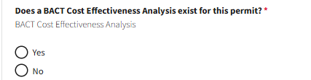
Figure 70
Once a file is uploaded, the new file will display in the “Permit Package Documents” table with a status of “Pending” in the “Submission Date” column. Users can delete any “Pending” file by selecting the trash can icon in the “Remove” column of the table. Associated “Document Categories” and “Descriptions” will also display in the “Permit Package Documents” table (Figure 71.) Users can repeat this process to add additional supporting documentation to the RBLC DEM form as needed.
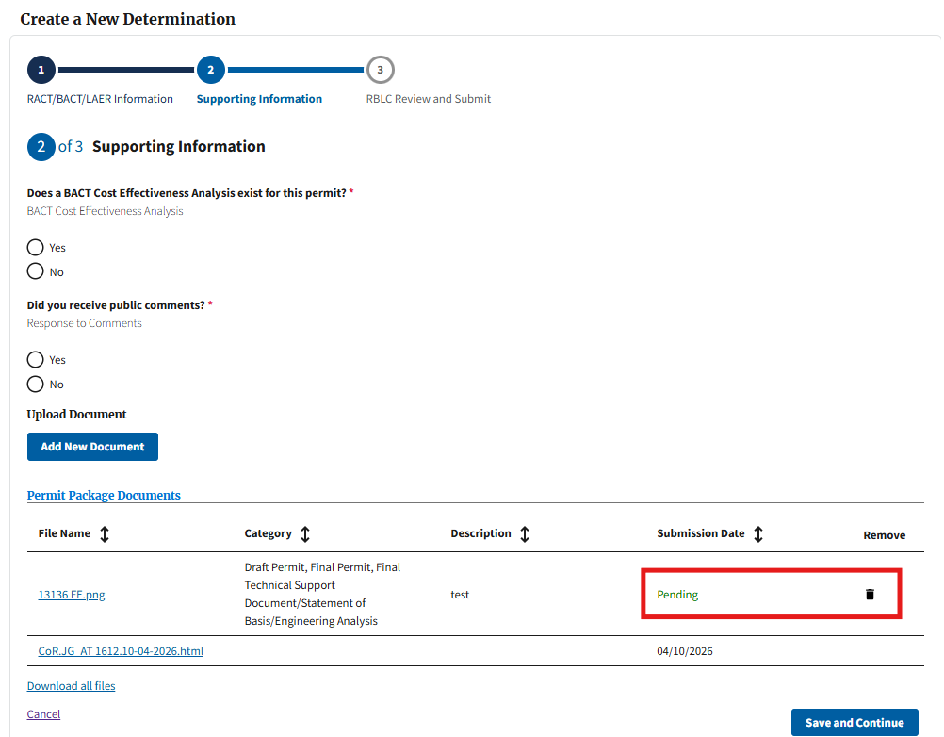
Figure 71
Note: For PAP users, all files uploaded on the “Supporting Information” page of the PM will display with a submission date in the “Permit Package Documents” table on the “Supporting Information” page of the DEM form.

3.3 Submitting a DEM form
Once all the required fields have been populated on the first two pages, users will proceed to page 3, “Review and Submit” (Figure 72.) On this page, users can review all RBLC data as well as all files uploaded on the previous page, shown in the “Permit Package Documents” table.
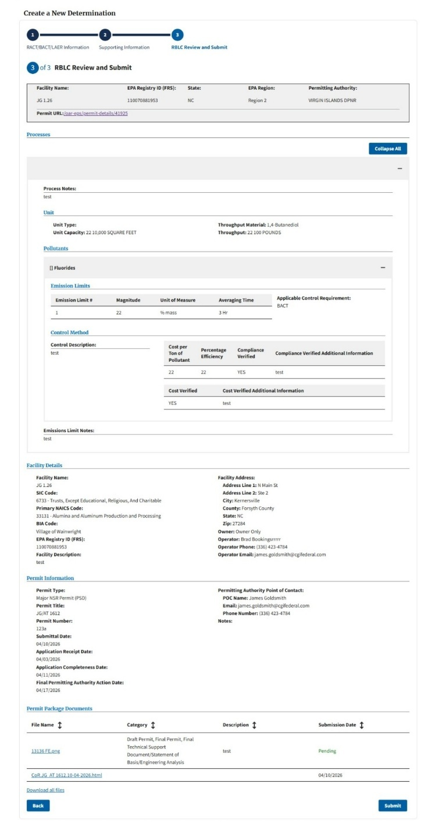
Figure 72
If users see any data they would like to edit, they can click on the text in the progress tracker (at the top of the form) of the respective page, to navigate to that page and make the necessary edits. Click the “Save and Continue” button on any pages that received edits. Once users verify the data is accurate on page 3, click the “Submit” button on the bottom of the page to complete their RBLC DEM submission (Figure 73.)
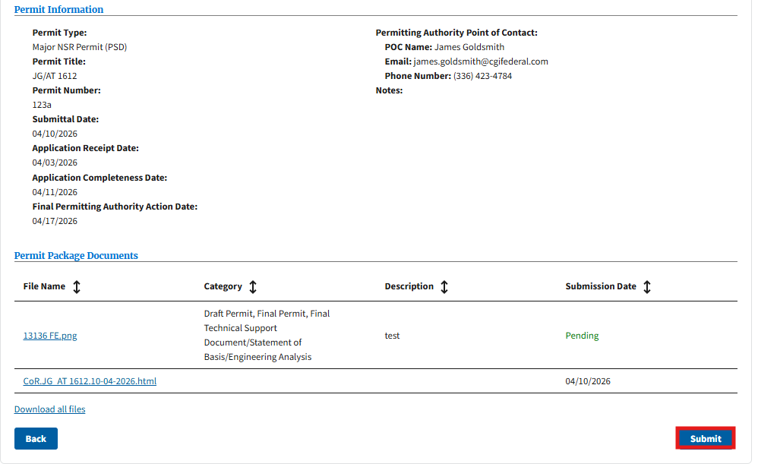
Figure 73
Users will be navigated to the “Permit Review” page. The RBLC COR and all supporting documentation submitted in the RBLC DEM will be available in the “Permit Package Documents” table.
Note: For RBLC-PAP users, when navigating back to the “Air Permits” table, the submission displays as “RBLC Submitted” in the “Status” column.
All submitted RBLC data will become available for the public to view within the RBLC Search Dashboard. All documentation provided in the RBLC DEM will be accessible to the public via the Permit Hub within the PM record associated to the respective RBLC DEM submission.

4.0 Glossary
Below is a glossary of acronyms and terms found throughout the CAAPS application and this user guide.
Acronyms/Terms | Definitions
BIA | Bureau of Indian Affairs
CAA | Clean Air Act
CAAPS | Clean Air Act Permit System
COR | Copy of Record
DEF | Data Entry Form
EPA | U.S. Environmental Protection Agency
EPA POC | U.S. Environmental Protection Agency Point of Contact
EPS | Electronic Permit System
FARR | Federal Air Rules for Indian Reservations
GP | General Permit
HAP | Hazardous Air Pollutants
NAICS | North American Industry Classification System
NSR | New Source Review
OCS | Outer Continental Shelf
OP | Operating Permit
PA | Permitting Authority
PM form | PM Form
PAL | Permitting Authority Landing
PAL (Source and Permit Type) | Plantwide Applicability Limit
PAM | Permitting Authority Manager
PM | Permits Module
PAP | Permitting Authority Preparer
RBLC | Reasonably Available Control Technology/ Best Available Control Technology/Lowest Achievable Emission Rate Clearinghouse
RBLC DEM | Reasonably Available Control Technology/ Best Available Control Technology/ Lowest Achievable Emission Rate Clearinghouse Data Entry Module
RBLC-PAP | Reasonably Available Control Technology/ Best Available Control Technology/ Lowest Achievable Emission Rate Clearinghouse Permitting Authority Preparer
SLT | State/ Local/Tribal
SLT PA | State/Local/Tribal Permitting Authority
ZIP | Zone Improvement Plan

