Reviewing a Permit
This job aide is intended to assist the Regional Administrator in reviewing previously submitted permit applications for Class I, Class II, Class III & Class IV wells within the Underground Injection Control application.

Select a hyperlink below to navigate to a specific section:
- Selecting A Region
- Accessing Submitted Permit

Selecting a Region
- The UIC application consists of 10 regions.
- Each user selects a “Home” region during the registration process and that region can be found that the top left of the landing page.
- See Figure 1a: Clearinghouse Region
  - 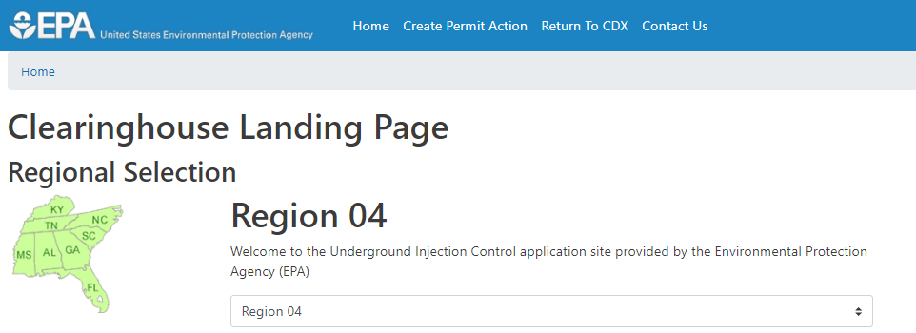
- The user can view permits submitted to other regions by selecting the region number from the drop down.

Accessing Submitted Permits
- An EPA user can open a selected permit via the Permits Submitted table.
  - All permit applications that are submitted have been signed by the RCO, and are available for download.
- Click on the “Download” button for the desired application. (see image below)
- A zip file will download once the link within the well name column is selected.
  - 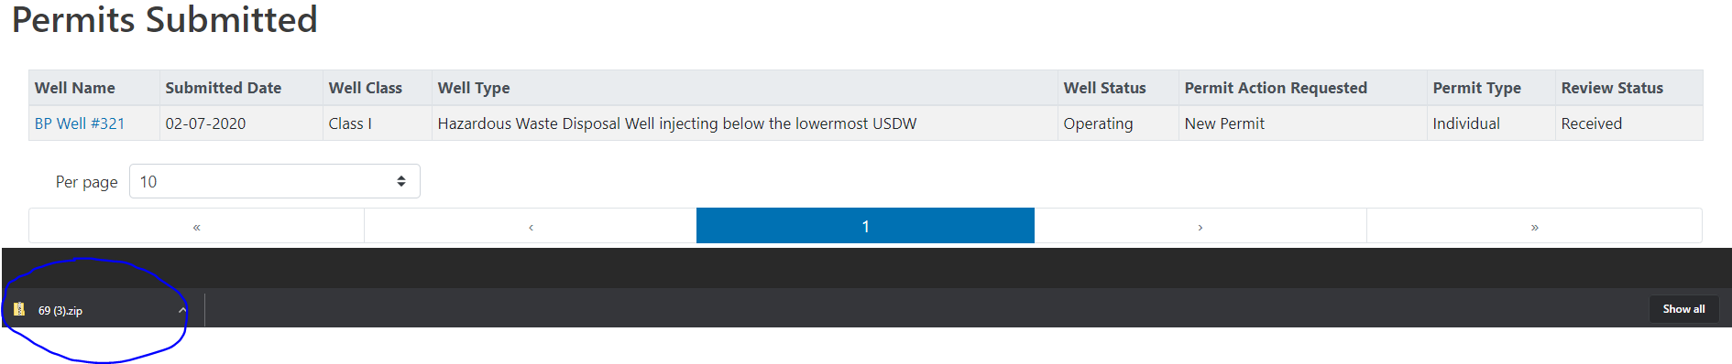
- When the user opens the zip from the bottom navigation, the HTML and any attached files will be listed.
- 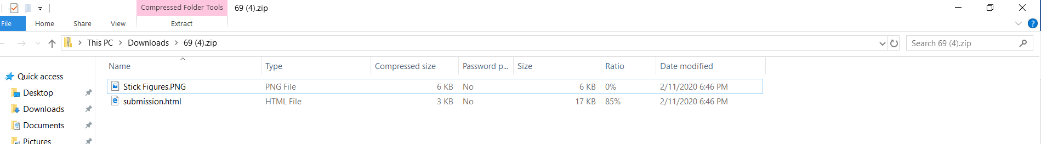
- If the user clicks on the “Submission.html” document, a read only copy of the submission will be presented (See image below of blank HTML)
- 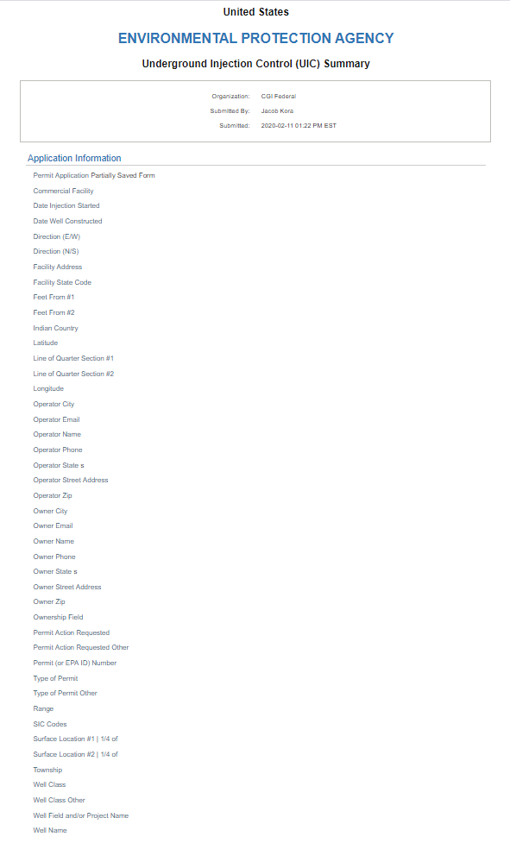
- If the user selects the file attachment, the file will open.

