Registering for Roles in Underground Injection Control (UIC)

Note: This guide is intended to provide an overview of the CDX registration tools for use by individuals responsible for managing access to Underground Injection Control application. There are several sections to this job aide. Select a hyperlink below to navigate to a specific section:
- Creating a Role
- Sponsoring a User
- Requesting that an RCO Sponsor your Role
- Approving a Request as a Sponsor
- Support

Overview
- Organizations will have the opportunity to create roles for Preparer, Duly Authorized Representatives (DAR), or Responsible Corporate Officials (RCO).
- UIC employs role sponsorship.
- Role Sponsorship will allow organization users to join UIC in one of two ways:
  - RCO’s can invite another organization member (via email) to join UIC as a DAR or Preparer.
  - Preparers and DARs can ask their organization’s RCO to grant them access to UIC via email.
- In order for users to gain access to UIC, the RCO of the organization must create a role first.
- NOTE: Sponsorship email occurs via email notifications.
Creating a Role
- Login to https://cdx.epa.gov
- Click on “Register with CDX”
  - 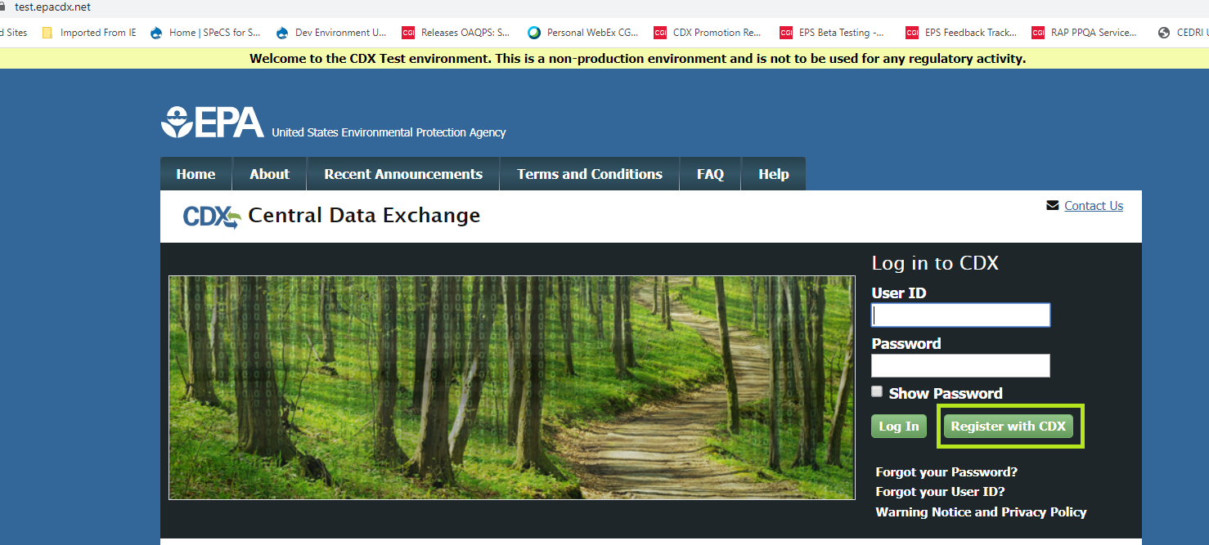
- Check the box associated with the statement: “I am this registrant. I will not share my account, and I accept the terms and conditions above.”
- Click on the green “Proceed” button.
- Type in UIC in the “Active Program Services List” field, and select the “UIC: Underground Injection Control” option. (See image below)
  - 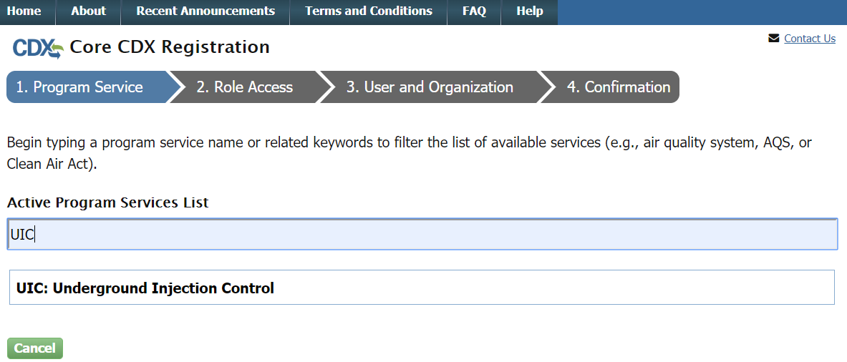
- Select “Responsible Corporate Officer” option from the “Select Role” drop down. (See image below)
  - 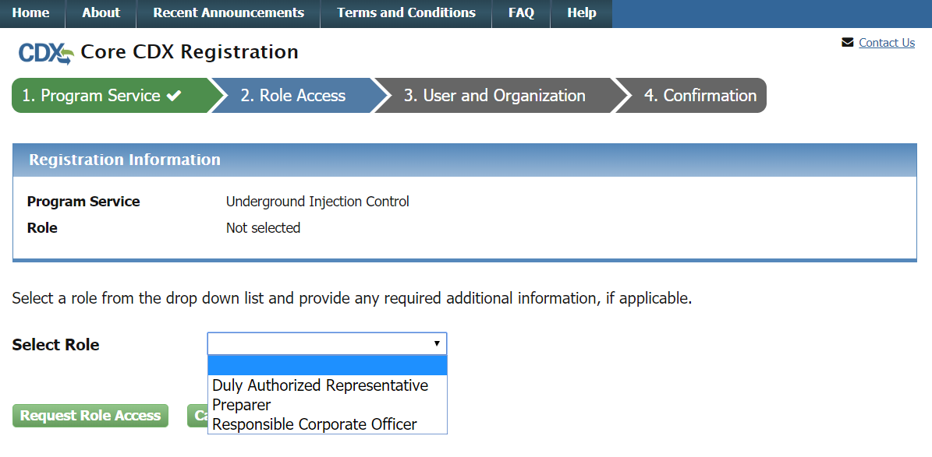
- Complete the “User Information” section (See image below)
  - 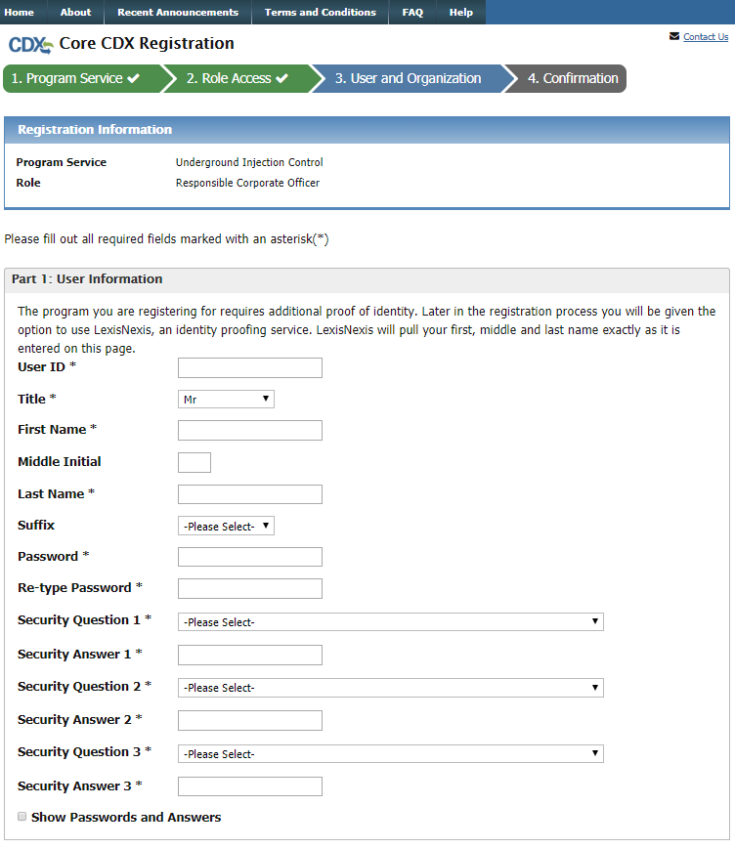
- Complete the “Organization Info” section (See image below)
  - 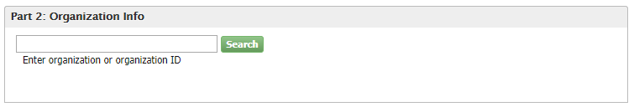
  - It is very important that the user selects the correct organization
    - A user may search by the following criteria by clicking on the “Advanced search” button. (See image below)
    - 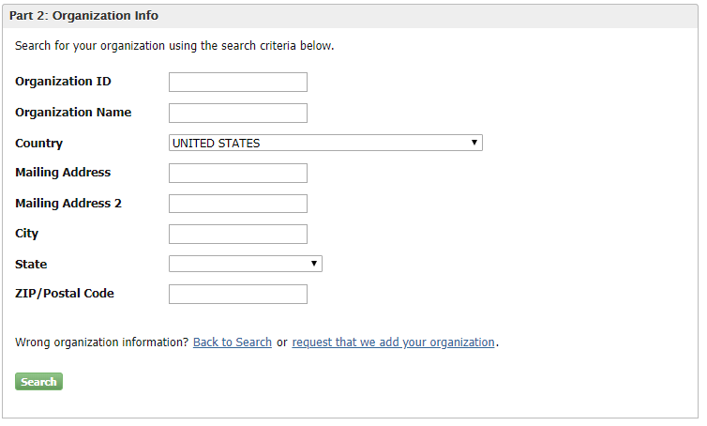
    - If your organization is not found, then select the “Request that we add your organization” link.
  - Once the user has found and selected the correct organization the following fields must be completed (See image below):
    - 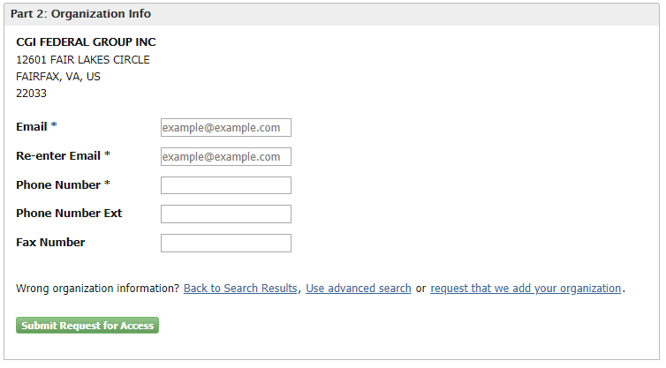
    - NOTE: An active email address is needed to complete registration.
  - After the email and contact fields are completed, select the “Submit Request for Access” button to continue.
- An email titled “Core Registration Email Verification Request” will be sent to the emails provided in User/Organization info.
- Take the code provided in the email in the “Code” field in the Confirmation page & click the “Create Account” button. (See image below)
  - 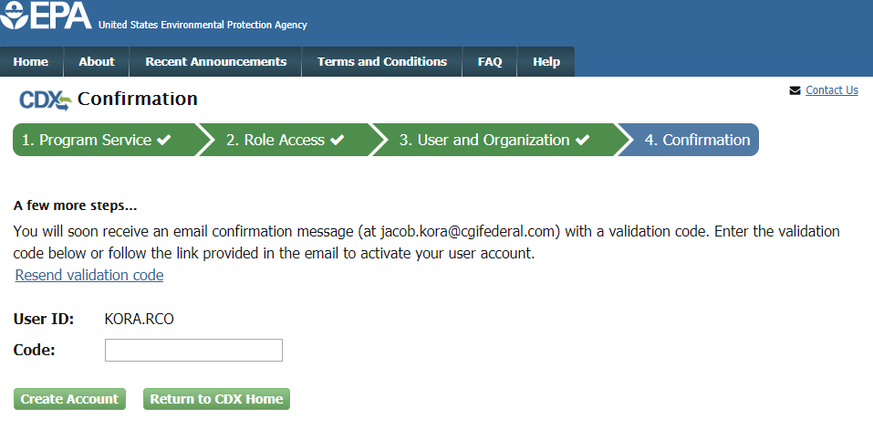
- Complete the Identity Verification & ESA Section via LexisNexis
  - It is important to include the most accurate information possible. (See image below)
  - 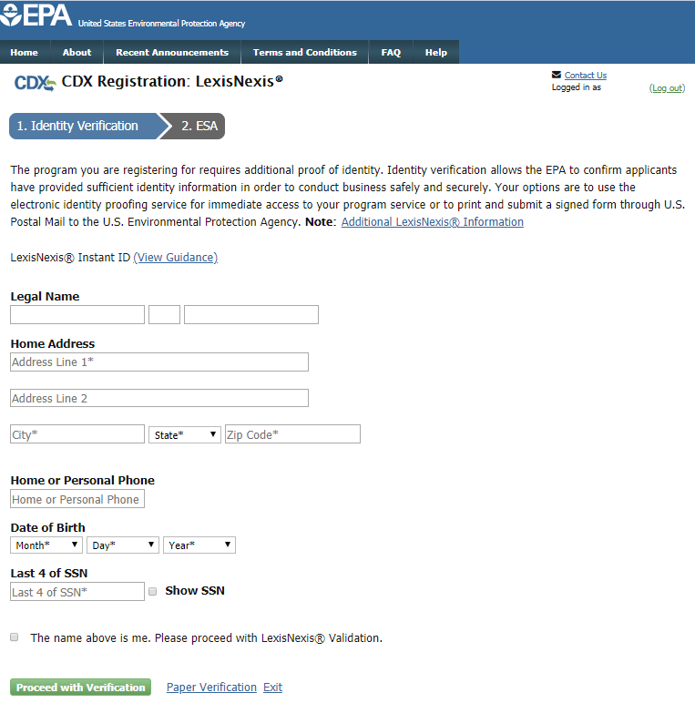
  - Once the LexisNexis registration is complete, the user will be ushered to the following page in CDX.
    - Note that the user cannot select the role. (See image below)
    - The user will be able to select the role once the role is activated by a manager in CDX.
    - 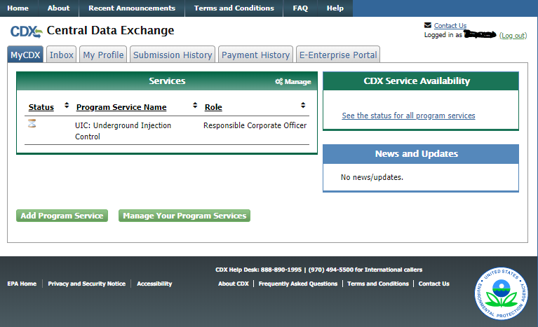

Sponsoring a User
- Log into CDX as an RCO user
- Select the “Role Sponsorship” tab within CDX (See image below)
  - 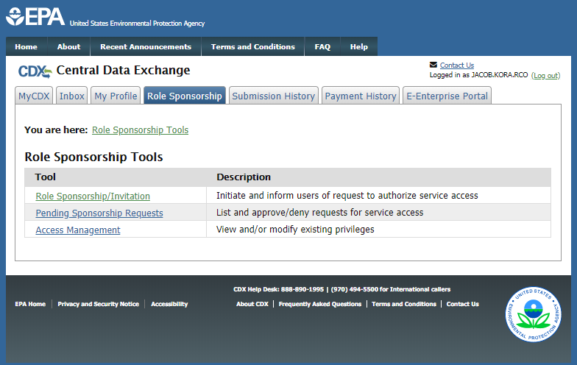
- Select the “Role Sponsorship/Invitation” table in the tool column.
- Include the user that you would like to sponsor in the email field.
- Make sure that “UIC: Underground Injection Control” is selected in the “Program Service” field.
- Select the appropriate role for the new user (Preparer or Duly Authorized Representative)
  - 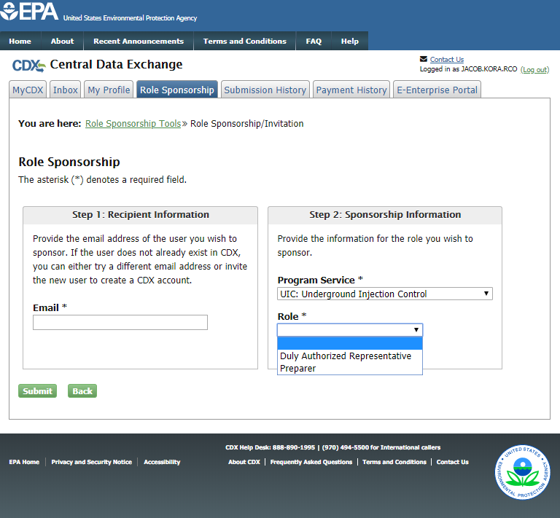
  - Select “Yes, the provided email address is correct, and the confirm email.
  - 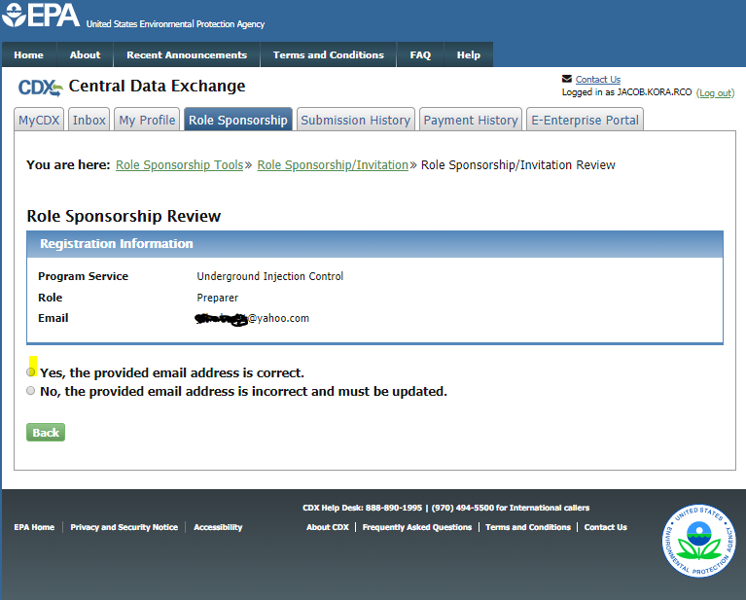
- An email titled “Central Data Exchange Sponsorship Request” will be sent to the email provided.
  - That user will be prompted to complete the registration process.

Requesting that an RCO Sponsor Your Role
NOTE: Before starting this process, you MUST KNOW the Responsible Corporate Officer’s email associated with their RCO role in CDX. You will need to confirm your RCO’s email before starting this process.
- Click on “Register with CDX”. (See image below)
- Check the box associated with the statement: “I am this registrant. I will not share my account, and I accept the terms and conditions above.”
- Click on the green “Proceed” button.
- Type in UIC in the “Active Program Services List” field, and select the “UIC: Underground Injection Control” option. (See image below)
- Select “Responsible Corporate Officer” option from the “Select Role” drop down. (See image below)
- Complete the “User Information” section. (See image below)
- Complete the “Organization Info” section. (See image below)
  - It is very important that the user selects the correct organization
    - A user may search by the following criteria by clicking on the “Advanced search” button. (See image below)
    - If your organization is not found, then select the “Request that we add your organization” link.
  - Once the user has found and selected the correct organization the following fields must be completed: (See image below)
    - NOTE: An active email address is needed to complete registration.
  - After the email and contact fields are completed, select the “Submit Request for Access” button to continue.
- An email titled “Core Registration Email Verification Request” will be sent to the emails provided in User/Organization info.
- Take the code provided in the email in the “Code” field in the Confirmation page & click the “Create Account” button. (See image below)
- Include your RCO’s email in the email field. (See image below)
  - 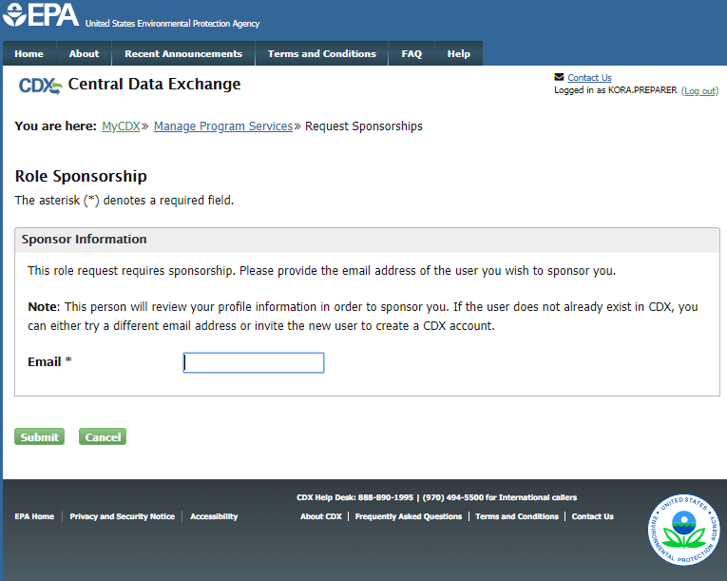
- Once you confirm the RCO’s email, you will be ushered to the cdx log in page.
- Note that the sponsorship request notification is available. (See image below)
  - 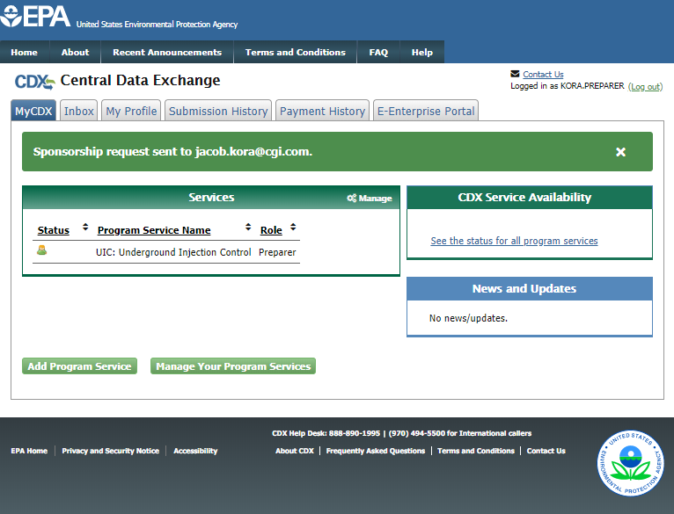
- After the RCO approves the request, your role will be accessible.

Approving a Request as a Sponsor
- If a DAR or Preparer has requested that an RCO sponsor their role, the RCO will receive and alert via email.

- Log into CDX as an RCO.
- Select the “Role Sponsorship” tab within CDX. (See image below)
  - 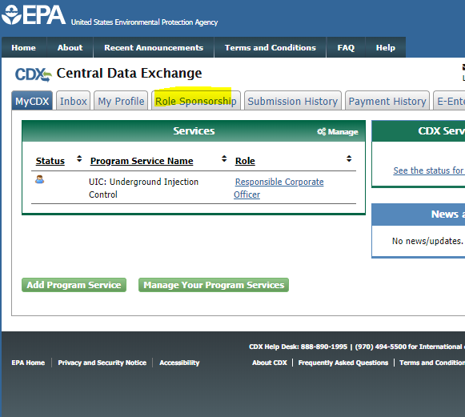
- Select “Pending Sponsorship Requests”. (See image below)
  - 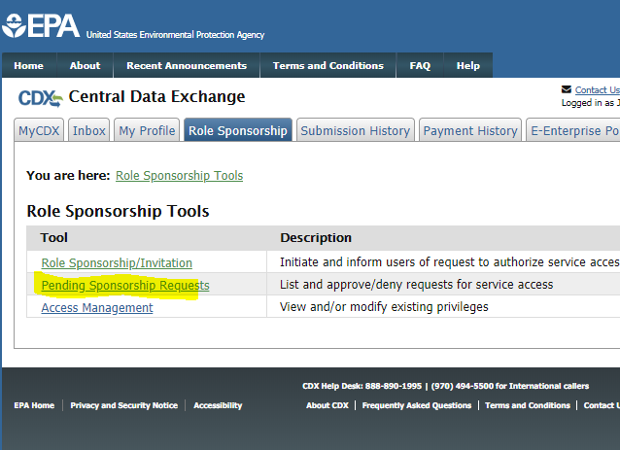
- Include “UIC” in the “Program Service” field then search.
  - 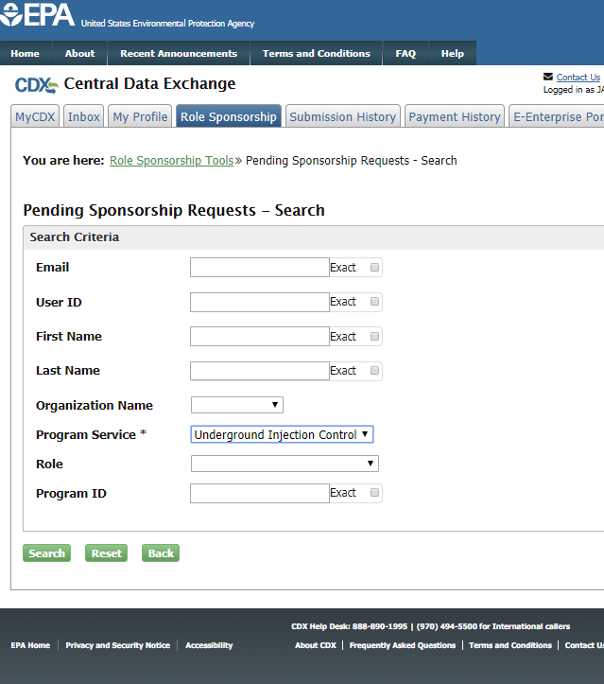
- If the user is allowed to gain access to UIC via your organization, then the RCO should select the “Approve” button. If the user is NOT allowed to gain access to UIC via your organization, then the RCO should select the “Reject” button. (See image below)
  - 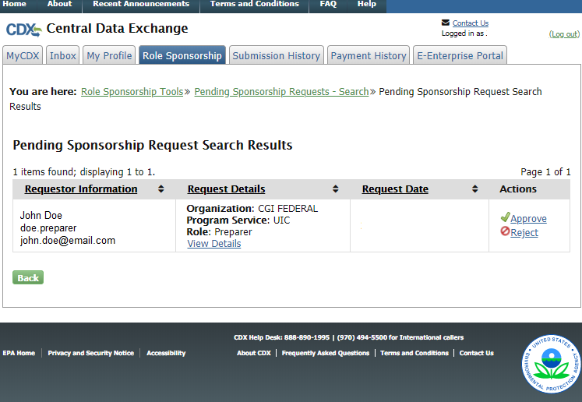
- Once the selection is made, follow the Electronic Sponsor Agreement form.
- And sign it electronically with your RCO Password, Confirmation Question, and the hit the “Sign” button.
- At this point, the user that the RCO just approved will receive an email to log into cdx titled “Action Required: Central Data Exchange Sponsorship Request Completed”.
  - NOTE: If the new created user does not log in using this link, then that user will not be able to access UIC.

Support
If you have any questions related to CDX or the Electronic Permit System program service, please contact the CDX Help Desk at helpdesk@epacdx.net or by telephone at 888-890-1995.

